Al-Farabi Kazakh National University

Moodle Distance Learning Guidelines
for students studying with the use of distance educational technologies

Almaty, 2018
Content:
Introduction
Moodle is an abbreviation for Modular Object-Oriented Dynamic Learning Environment (Modular Object-Oriented Dynamic Learning Environment). Moodle is a free learning management system, focused primarily on the organization of interaction between the teacher and students, although it is also suitable for organizing traditional distance learning courses, as well as supporting full-time study.
The Moodle training course includes a set of information materials used to create the theoretical basis of the course (text documents, presentations, links to Web pages, multimedia materials), materials for knowledge control (usually automated tests or assignments), as well as materials for communication and interaction with the teacher (forums, chats, messaging, etc.).
The following is a detailed instruction for students on using the resources of the Moodle platform.

1. Access to the course
Access to the website of distance learning of KazNU named after al-Farabi is carried out by the link: http://dl.kaznu.kz/

The main page of the site is shown in the figure:

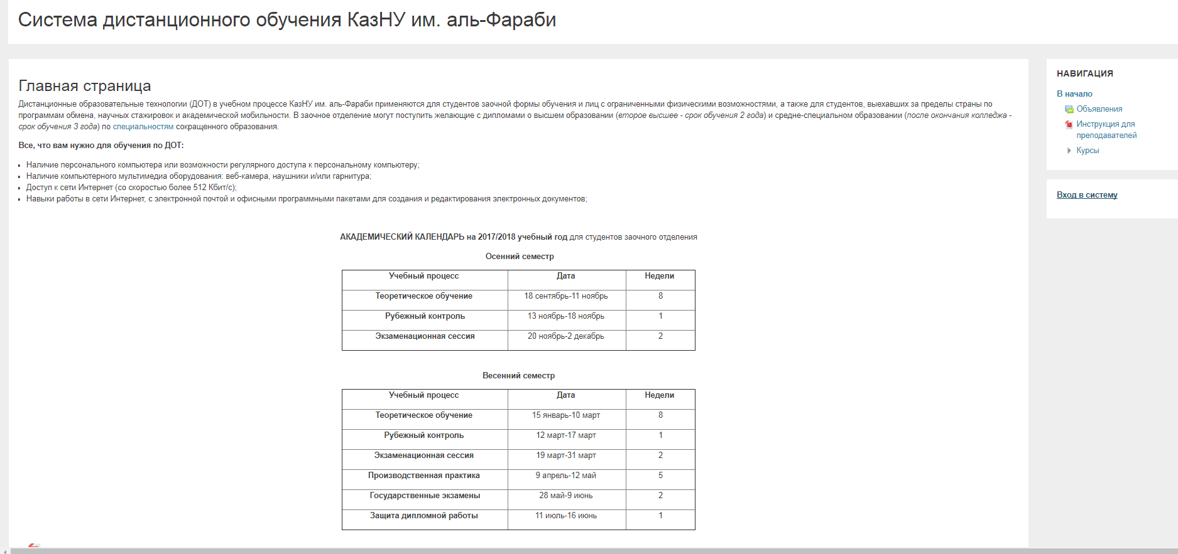
Distance Learning System of al-Farabi KazNU
Main page NAVIGATION

To enter the system you need to log in by clicking on the “Login” button (located in the upper right corner of the page):
NAVIGATION
To the beginning
- Ad
- Instructions for teachers
- Courses
Logging in

Next, in the window that opens, you must enter the login (username) and password that you took from your tutors in the faculty and click the "Enter moodle" button:

Enter your username and password
login
smagulova.shynar
password

As a result, the student’s personal page opens, containing a list of courses available for study (Summary of courses is in the middle).

shynar. smagulova
course summary
Training course for faculty staff

For some courses, warnings about the presence of tasks, that must be completed, may be indicated.
When you log in for the first time, you must first make all the settings necessary for convenient further work, as well as configure the user profile.

User profile setup
After authorization, the student gets to the main page of the course. In this case, the user name located in the upper right part of the page is highlighted as a hyperlink.
You are logged in as shynar smagulova (logout)

Clicking on this link opens a user profile, the settings of which can be changed if necessary.

Shynar smagulova
- Personal Area about user
User Details
- Edit information
- Country
- Kazakhstan
- Town
Almaty
Course Information
- Course participant
Others
- Blog posts
- Forum Posts
- Formus Themes
- educational plans
Reports
- browser session
- grades overviews
Logins
- First access to the site
dates
- Last access to the site
Dates

To change the profile, click on the link “Edit information”
As a result, a form will open in which the user can fill in the new meanings of the main fields (Name, Surname, Email address, New username and / or password, place of residence, etc.), enter additional information (interests, contact details - phone, Skype, ICQ, etc.), as well as upload a personal photo (recommended).
After filling in all the required fields, clicking on the “Update Profile” button will save all the changes made.

Course Navigation
Go to the course content by clicking on the link containing its name.
COURSE SUMMARY
Training course for faculty staff

This transition can be carried out by choosing a link to the course located on the main page of the site or in the side menu.
Personal Area
Homepage
The calendar
Personal files
My courses

When choosing a course, its main page opens:
Personal Area - My courses
First we follow the announcements and discuss general issues on the course
Sample Section
September 21 - September 27
materials
dates

The logo of the site and the name under, which you are authorized, are located at the top of the page.
Below the Navigation Bar is displayed, which shows the location of the current page in the site hierarchy. Elements of this menu are links, clicking on which you can return to the pages of higher hierarchical levels.

Private Office > My courses >

Using this panel, you can always see in which section of the course you are and go to higher-level section of the site.
Below the navigation panel, the page is divided into 2 columns. The columns around the edges of the page contain blocks, and the middle wide column of the page is occupied by its content (for example, sections of the course).

Content of the course

4.1 The study of the theoretical material
Each training course is structured by sections or topics (in our case, the course is structured by weeks). Each section usually contains theoretical material for study, additional materials and materials for knowledge control. After opening the training course, you will be able to:
- The training materials that the teacher had posted for your course / group. These can be downloadable files, audio and video presentations, links to web pages , or just text; each type of training material has its own image;
- Actions – tasks that the teacher has planned and that you will need to complete by a certain deadline, each type of task has its own image;
- "Upcoming events” of the course – here you can see both lectures and actions planned by the teacher that should happen in the near future.
in Russian
in English
The first follows the announcement and discuss general questions on the course
> announcement
> questions and discussion

Example of section
> Example of training material
> Simple task and lectures
> Testing on the lecture topic
> Leave feedback
> Questionnaire
> Quiz

September 21 – September 27
> Lecture example
> Essay on the topic 1

September 28 – October 4

October 5 – October 11

First, you need to study the theoretical material, which can be represented by individual files, pages, or hyperlinks.
in Russian
in English
Examples of lecture
Sample of educational material
Additional theoretical material

To view the material, click on its link, and then select one of the actions (open or save) in the window that opens.
After studying the material, you need to start performing control measures, which are presented in the form of practical tasks or automated tests.

4.2 Work with the practical tasks
Tasks allow the teacher to set aa task that requires students to prepare a detailed answer. Typical assignments include essays, projects, reports, etc.
The task conditions are selected by the teacher. For example, a task may have a time limit. The teacher can allow students to respond after the deadline, and the teacher will be shown information about overdue responses. The teacher can evaluate the work and leave comments both individually and on the same page for several students.
To view the task click on the corresponding hyperlink:
in Russian

in English
Simple task to lecture 1

As the result, a window opens containing recommendations for completing tasks:
in Russian
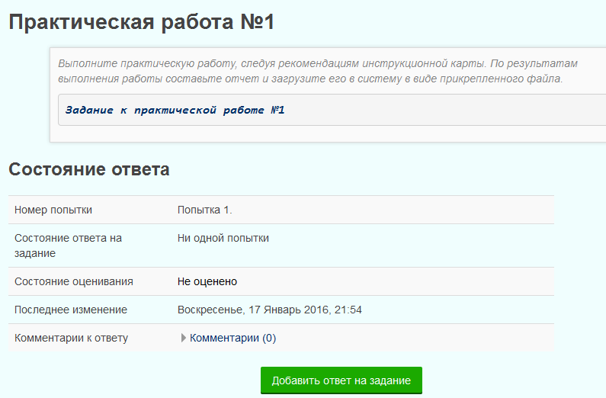

in English
Practical work №1

Complete the practical work by following the recommendations of the instruction card. Make a report based on the results of your work and upload it to the system as an attached file.

The task of the practical work №1

The response status

Attempt number Attempt 1.
Response status to the task No attempts
Status of evaluation Not evaluated
The last change Sunday, 17 January, 2016, 21:54
Comments on the answer Comments (0)

Add answer to the task

To send a response to the review to the teacher, click the "Submit task" button. Confirm sending by clicking the "Continue"button.
After submitting the task, the "response Status" table displays the text "Responses for evaluation" on a green background in the "task response Status"line.
You can add comments to the task while preparing it for submission, or even after it is submitted for review. To do this, click on the "Comments" text in the "Comments to the response" line, enter the comment text in the field that opens, and click the "Save comment"link. You can use the comment, for example, to notify the teacher when an incorrect response file is sent for verification.
Do the practical tasks, according to the recommendations in the instruction card. According to the result of the work compose report and download it into system in the way of attaching file
After reading the recommendations, open or download the instruction card to your computer (in this example, it is located at the link "Task for practical work №1").
As a rule, after completing practical work, you need to make a report in the form of a separate file, which must be uploaded to the system for verification.
To download the report, click the " Add answer to the task" button and in the window that opens, click the " Add " button located in the upper - right corner:
in Russian
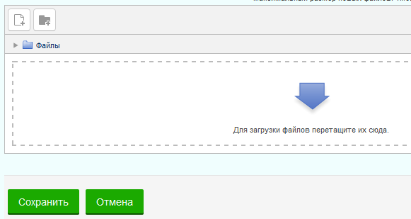
in English
Files

To upload files, drag them here.

Save Cancel
Next, in the "File selection" window, go to the "Upload file" tab
in Russian
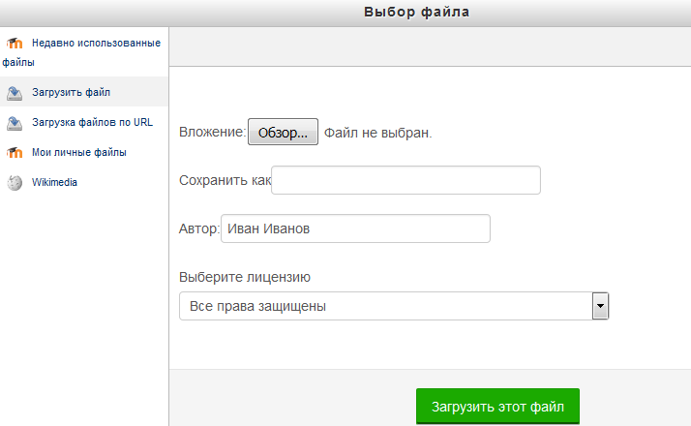
then click on the "Overview" button.
in English
 | Choice of File
- Recently used files  - Upload file  - Upload files by URL  - My personal files  - Wikimedia | The attachment Review The file is not selected  Save as _________________________________  Author __________________________________  Choose a license  All rights reserved  Download file

As the result, opens a dialog box where you can select a practice file.
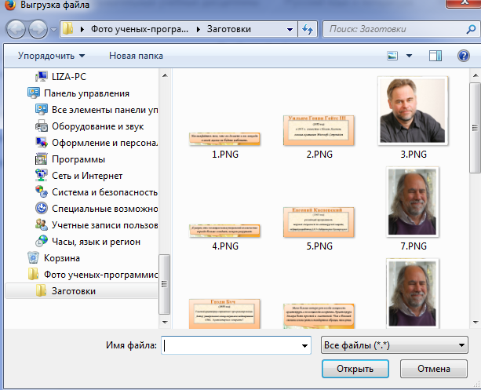

To send a response to the review to the teacher, click the "Submit task" button. Confirm sending by clicking the "Continue" button.
After submitting the task, the "Response status" table displays the text "Responses for evaluation" on a green background in the "Response status to the task" line.
You can add comments to the task while preparing it for submission, or even after it is submitted for review. To do this, click on the "Comments" text in the "Comments to the response" line, enter the comment text in the field that opens, and click the "Save comment" link. You can use the comment, for example, to notify the teacher when an incorrect response file is sent for verification.
After checking by the teacher, the task can be either credited or sent for revision. In this case, a notification can be sent to the listener 's e-mail address (only if you specify a real e-mail in the user profile settings ).
To see the result of the task verification , go to the “Tasks” page by clicking the “Tasks” link in the course “Elements” section. A table with all the course assignments is displayed. The "Assessment" column displays the teacher's assessment. If there is a dash in this field, the task has not been evaluated yet.
4.3 Testing
Almost every section of the course ends with an automated testing procedure. Most test tasks are evaluated automatically. If you change the task, the test may be re-evaluated. The teacher can define various restrictions for working with the test: the beginning and the end of testing, time delays between attempts, the number of attempts, access password, access only from certain network addresses. The teacher can configure the number of attempts to pass the test, specify comments for individual responses, and for all tests, depending on various conditions. When performing subsequent attempts, previous responses may be taken into account. In a single attempt, students can complete the test in multiple approaches. The teacher can get detailed information about students ' responses and the time they spend.
How to work with texts?
In order to pass the test, simply click on its name on the course page .
Testing as per the subject of Lecture 1
Do not rush and carefully read the information on the first page:
• Test start and end time
• Number of attempts to pass the test
• Test passing time

If any of these data are not specified, then this parameter is not limited.
In order to proceed to the test performance, click on the link with its name:
After studying the lecturer’s recommendations for passing the test, click on the “Test start” button:
The test page, as shown in the figure, is divided into 2 areas:

Navigation through the test contains a set of buttons with question numbers, by clicking on the button, you can proceed to the performance of corresponding test task. Also, if testing is limited in time, the remaining testing time is displayed on the Navigation Panel.
The central area of ​​the page contains a list of test tasks. At the same time, a grade point is shown for each task, which can be obtained for the correct answer, and it is also possible to mark the question.
The figure above shows the questions, suggesting the choice of one answer from several presented. To select the correct answer, click on the button next to it.
After answering all questions, a page opens containing statistics of all answers, on which you need to click on the button

In the next window, confirm sending by clicking on the same button
After sending, a window opens containing the test results (obtained grade point, % of correct answers, final grade and review):
Please note that in the Navigation Panel the correct answers are marked in green and the wrong - in red:
By clicking on the button with the question number, you can proceed to its view:

In order to finish viewing the test results and proceed to study the course, you must click on the link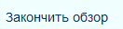.

The course elements
The course elements - are interactive modules, with the help of which the lecturer organizes the educational process in his course (places the course materials, conducts testing and communicates with the students). The system has a wide variety of modules that can be used to create courses of any type:
• SCORM/AICC
• Wiki
• Survey
• Database
• Glossary
• Assignments
• Lesson / Lecture
• Quiz
• Test / Choice
• Forum
• Chat
SCORM/AICC - is one of the elements of the course that allows the lecturer to publish any package of the SCORM or AICC format in his course. These packages may include web pages, graphics, Javascript programs, etc.
Wiki – “Wiki wiki” means “very fast” in Hawaiian. The Wiki allows users to write documents jointly using a simple markup language right in the browser window. Lecturers and students of the course can add and edit their materials, and observe the history of the wiki document creation.
Survey - this element represents built-in forms (COLLES, ATTLS) to conduct the research work that may be useful in grading and stimulation of training in distance learning courses.
Database - is a bank of records on any topic. The format and structure of the records is virtually unlimited, it can be images, files, numbers, text, etc. Records can be viewed in the list mode, one record at a time, and search form is also offered. The lecturer can determine various restrictions on working with the Database: time periods for viewing, adding records, restrictions on the minimum and maximum number of records.
Glossary - is an electronic dictionary of concepts and terms used in the course. The glossary can be shared across the entire course and separate for each topic. The lecturer can provide access to the glossary to users for collaborative work on the dictionary. Students’ records may be previewed by the lecturer before being published. Search may be done based on records. A review of records is possible in line with the alphabet, by category, by date and by author.
Assignment - 3 types of assignments/tasks can be offered to the listener:
• Answer - in the form of several files
• Answer – in the form of text
• Answer – in the form of file
Lesson/ Lecture - presents educational material in quite interesting and flexible form. It consists of a set of pages. Each page usually ends with a question that the student must answer. Depending on the correctness of answer, the student goes to the next page or returns to the previous one. Lecture navigation can be direct or more complex, depending on the structure of the material offered.
Quiz - the lecturer asks a question and identifies several answer choices. One of its applications - is to vote among students. This can be useful as a quick poll to stimulate thinking in order to allow the audience to vote on any question, or to find a common opinion in the process of problem study.
Quiz passing may be limited in time. The quiz results can be opened for viewing, closed, or open after completion of quiz. Also, the quiz form can be used, for example, for distribution among the groups with a limited number of participants.
Tests/ choices - are formed using various types of questions, let’s consider the main types:
- True/False
- Cloze
- Calculable
- Short answer
- Multiple choice
- Matching
- Random matching question
- Numeric
- Essay
- Description
True/False - the student chooses the answer to the question between the two choices “True” and “False”.
Cloze - are very flexible questions, consisting of text (in Moodle format), directly into which the answers are inserted. This type of question may include Short answers, Numeric, as well as Multiple choice.
Calculable - it is proposed to calculate the value by the formula. The formula is a template into which, at each test, random values ​​from specified ranges are substituted.
Short answer - the answer to the question is a word or short phrase. Several correct answers are allowed with different grades. Answers may (or may not) be case sensitive.
Multiple choice - the student selects the answer from several choices being presented. There are two types of multiple choice questions - with one or more correct answers.
Matching - the list of questions is displayed along with a list of answers. The student must compare each question with the corresponding answer.
Random matching question - the question is similar to the "Matching question", but is created from randomly taken questions "Short answer" from one or another category.
Numeric – it looks just like the Short answer. The difference is that the numerical answer allows an error in the answer. The student can indicate a continuous range of correct answers.
Essay - the lecturer may ask you to write an answer in the form of essay. The lecturer evaluates this answer manually.
Description - is not really a question. It is used to add instructions, categories or other information to the test, similar to the Explanation on the course page.
Forum - can have a different structure and allow you to evaluate messages. Forum posts can be viewed in four different formats and contain attached files. By subscribing to the forum, the participant will receive copies of all new messages to his email. The lecturer, if necessary, can forcibly sign everyone on the forum.
Chat - enables the course participants to conduct on-line discussions. This is a convenient way to get information about how students learned the material. The module contains several options for managing and viewing discussions.
Frequently-asked questions
Where can I get the login and password to log in to the Moodle system? You can take the login and password for entering the system from your tutors in the dean’s office. Access to the website of distance learning for part-time students of the 1st course is provided by the link: http://dl.kaznu.kz/
Why can't I log in?
One of the reasons may be that you enter your password or login incorrectly. Perhaps you used uppercase and/or lowercase letters in your login or password.
How do I know which courses I am enrolling in?
The list of courses for which you are enrolled is on the Front/Home page in the Navigation block - My courses.
How do I return to the Front/Home page?
Use the navigation bar in the upper right corner of the page or the “Home” button at the very bottom of the course.
How can I change the information about me?
On the left side of the page there is the “Settings” block, and there, in the “My Profile Settings” section, click on “Edit Information”. You will be taken to the personal information editing page.
Why am I not receiving messages from the forum to my e-mail?
In order to receive copies of messages from the forum, you must subscribe to the forum. Please note that at the top of the screen there is a comment: "In this forum, each participant can choose whether to subscribe to it or not." Click: "Subscribe to the forum."
How can I see my grades?
In order to view your grades, go to the desired course, and in the Settings block, select Grades. You will receive a report on this course.

