CONTENT

 | Introduction | 3
 | Description of the final control (exam) forms during the session of the autumn semester of the 2020-2021 academic year | 5
 | Written exam: traditional - answers to questions of LMS Oqylyq | 9
 | Written exam: traditional - answers to questions Univer IS | 12
 | Written exam: project, creative task | 17
 | Written exam: case task | 21
 | Written exam: essay | 25
 | Exam - testing | 28
 | Oral exam: traditional - answers to questions | 35
 | Combined exam №1 project work with subsequent oral defense | 40
 | Combined exam № 2: project work using Miro interactive whiteboards with subsequent oral defense | 46
 | Combined exam number №3: written (case assignment/creative assignment) + testing | 53
 | Alternative exam - MOOC certificate re-registration (Coursera, Stepik, edX, etc.) | 60
 | Appendix 1. Instructions for loading test questions into the Moodle LMS | 61
 | Appendix 2. Setting up limited access in LMS Moodle | 73
 | Appendix 3. Template of a test set for the Univer system | 76
 | Appendix 4. Description of work with the Antiplagiat system | 77
 | Appendix 5. Sample Coursera Certificate and Listener Profile with estimates | 80
 | Appendix 6. List of assessment tools for current, final control | 81
 | Appendix 7. Rules for setting up the choice of the forms and platforms for final control in Univer IS | 83

INTRODUCTION

CHOOSING AN EXAM FORM

The main criterion - the choice of the exam form DIRECTLY DEPENDS ON THE EXPECTED TRAINING RESULTS.

The exam form should be relevant to the task of assessing expected results. Example - the test is not suitable for assessing the formation of analytical thinking skills. Students have to conduct a case analysis or writing a project forecast.
The choice of forms and platforms is carried out by teacher personally in IS Univer in the "Teacher" tab - "Forms and platforms for the final control".
The choice of the teacher is approved by the head of the department and the chairman of the methodological council of the faculty.

EXAM SCHEDULE
IMPORTANT - the exam is held on schedule.
Students and teachers should be informed in advance about the schedule of exams - the responsibility of the leadership of the departments and faculty.
All dates and time in exam schedule indicated according to the time of Nur-Sultan.

DISTANCE EXAM FORMATS:
- synchronous;
- asynchronous;
- hybrid.

1. Synchronous format - the student takes the exam in real time "here and now".
Test - an automatic proctoring system, a proctor or a teacher (in the absence of proctoring) monitors the passing of the test.
Oral exam - the student, according to the exam schedule, contacts the teacher or representatives of the examination committee through the online platform for webinars corporate connections Microsoft Teams, BigBlueButton in Moodle LMS are recommended (in case of technical problems - ZOOM, Skype and others). The Commission shall ensure the video recording of the exam and the preservation of the video recordings within 3 months from the date of the end of the session.
Written exam - a student according to the exam schedule takes an exam on an online platform (Oqylyq LMS or IS Univer) by filling in the answer fields to the questions of an automatically generated exam ticket. An automatic proctoring system or proctor supervises the passing of the exam.

ATTENTION. The use of headphones, including wireless ones, is permitted only at the time of receiving additional questions from the members of the examination committee during the oral examination. In all other cases, the use of headphones is PROHIBITED.

2. Asynchronous format - the task is performed by the student NOT in real time, but with a delay in time and with the condition of completion of the work on the dates of the exam (deadline). The teacher or proctor does NOT observe the student's work “here and now”. All works will be check after their completion. All works are checked for originality (absence of plagiarism - illegal borrowing from other people's texts).
Project, creative assignment, essay.

Lecturer formulates tasks, determines the rules and timing of the exam. The student receives an assignment through the official information and educational system of the university (LMS Moodle), performs and sends the completed task for verification of the task through the official information and educational system of the university (LMS Moodle).

SENDING EXAM PAPERS BY E-MAIL, MESSENGERS OR IN ANY OTHER WAYS IS PROHIBITED.

3. Hybrid format - synthesis of synchronous and asynchronous formats. Practiced in combined exams.

APPROVAL OF LECTURER MATERIALS FOR EXAMS:

- in Univer informational system (IS) - a traditional automatic system of approval by chairmen of method councils and heads of departments;
- in the Moodle LMS - chairmen of methodological councils check examination tasks and materials by logging into the system under an account issued by INET individually for each faculty.
Then chairmen of methodological councils submit to the Vice-Rector for Academic Affairs a submission (drawn up NOT in the Moodle LMS, but in the traditional WORD document format) on the approval of lecturer materials: test sets, tasks for essays, projects, case assignments.
The submission is sent by e-mail to the deputy deans for educational methodical work of faculties.

TIMING

The exam lasts from 60 minutes to several weeks, depending on the form.
Time limit for assigning points to the attestation paper: up to 72 hours. It is possible to revise the duration by decision of the Department of Academic Affairs. There may be a delay in scoring to take into account the results of online proctoring.

Description of the forms of the final control (exam)
during the session of the autumn semester of the 2020-2021 academic year

The form of the final control (exam)* | Platform used | Recommended for | Availability of proctoring, video recording, plagiarism check | Possibility of automatic generation of exam papers | How the work is checked  Exam assignments for all types exams approves by  head of department and chairman of the faculties methodological council  one month before the session.
WRITTEN  TRADITIONAL  typing in the editor window.  NOT PROVIDED  answer form,  written by hand on paper.  Question amount 10-30: questions on the application of knowledge  regardless of the number of students, regardless of loans for any level of education. | External platform LMS Oqylyq  Univer IS | For undergraduate, graduate, doctoral students.  Socio-humanitarian direction and exams that do NOT require writing complex calculations, formulas, etc. | Proctoring  in LMS Oqylyq - yes.  Check for plagiarism in LMS Oqylyq - yes.  Proctoring in IS Univer - no.  Checking for plagiarism in IS Univer - yes. | Exam papers are generated automatically | - Lecturer of the discipline receives the completed examination papers in the Oqylyq / Univer system.  - Evaluates work in the Oqylyq /Univer.  - Transfer points to the Univer system.
WRITTEN:  - project  - case,  - essay,  - creative task. | LMS Moodle | For students of bachelor's, master's, doctoral studies.  Natural science, technical, creative specialties, etc.  Essay  Methodical Council of Faculties determines the limit on the maximum number of characters and the maximum time for providing answers  depending on the level of education (bachelor's, master's, doctoral studies) | Proctoring - no.  Video recording of the work on the project in case of group execution is required.  Group Discussion Videos Required (at least 2 discussions) ONLY by student-organizer of videoconferencing (video conference).  Video recording for individual work is not required.  Checking for plagiarism is mandatory in the work of students with group and  individual work.  There is an automatic check of work for plagiarism using  Antiplagiat.ru. 1 check for 1 job.  When using the Antiplagiat system, lecturer can provide an opportunity to check the work for a student -  1 attempt (configures by teacher). | No | - Lecturer of the discipline receives files/answers in the Moodle LMS.  - Evaluates the work, chec it for plagiarism.  - In the case of group work, examines the videos of the group.  - 4. Puts points in the Moodle LMS.  - Transfer points to the Univer system.
TESTING  Question type is multiple choice.  300 questions - topical VOUD disciplines IS NOT changed.  If the old VOUD discipline or for all the rest:  150-200 questions excluding credits. From 1 or more correct answers FOR LECTURER DECISION. | Univer IS  Amount of questions in exam test - 40 questions for any number of questions in the test set.  1 attempt  Time -  90 minutes. | For undergraduate students.  FORBIDDEN  testing in Univer IS at the master's and doctoral levels.  For large groups of students, as well as for 1st year students.  If the teaching staff has ready-made tests, then for any level. | Proctoring - yes. | Exam papers are generated automatically | The system checks the answers automatically against the keys of correct answers.
TESTING  At least 4 types of questions in equal proportions in 1 test set (types: multiple choice,  True/false,for compliance,  short answers, numeric input, calculated, nested responses, essays, etc.)  Separation into separate categories is mandatory.  25-100 questions  1 credit = 25 question.  2.3 credits = 50 question.  4.5 credits = 75 question.  6,7,8 cred. = 100resp.  The general framework for the minimum number of test questions.  Each faculty determines independently.  Consultations at  necessity - INET. | LMS Moodle  The number of test questions during the exam – 25 questions for any number of questions in the test suite.  An equal ratio of at least 4 categories is mandatory.  1 attempt  Time - 60 minutes. | For students of bachelor's, master's, doctoral studies.  For small groups up to 50 people. | Proctoring - yes  or,  in the absence of proctoring, video recording for groups of up to 20 students inclusive. The responsibility for the video recording is with the teacher.  Recording is required MANDATORY. Responsibility for video recording and its preservation within 3 months after the end of the session - at the teacher and the department. | Exam papers are generated automatically | The system automatically checks the answers according to the keys of correct answers, except for the "Essay" type of tests.  The teacher evaluates the type of test "Essay" himself.  Lecturer transfersscores to the IS Univer statement.
TESTING  150 questions excluding loans  FOR THE DISCIPLINE OF THE PEP  The question base includes different types of questions. | StartЕxam  The methodological council of the faculty determines the number of questions and the time for passing the test. | Faculty of Medicine and Healthcare only | Proctoring - yes | Exam papers are generated automatically | The system automatically checks the answers according to the keys of correct answers.  Lecturer transfer sscores to the IS Univer statement.
ORAL EXAM  Question amount - 10-30 questions for the application of knowledge,  depending on the number of students,  (regardless of credits for any level of education). Educational results can be combined in one question. | Мicrosoft Teams  or  BigBlueButton  in LMS Moodle | For students of bachelor's, master's, doctoral studies  Small groups of up to 10 people. | Proctoring - no  Video recording – yes  Recording is required MANDATORY. Responsibility for video recording and its preservation within 3 months after the end of the session - at the teacher and the department. | Exam papers are generated automatically | For students of magistracy, doctoral studies  (accepts by the teaching staff ofthe discipline).  For undergraduate students (accepted by the examination committee, at least 2 people).  If necessary  the teacher himself can be included in the commission and become one of the examiners).  If the BigBlueButton platform is selected  in LMS Moodle in INET submission is submitted  from the faculty by connection to the course of the members of the examination committee.  Certification of students is carried out  Lecturer or commission chairman transfer sscores to the IS Univer statement.  No protocol required.
COMBINED №1.  Written draft followed by oral defense. | Written part - LMS Moodle  The oral part - Microsoft Teams, or  BigBlueButton in LMS Moodle.  Alternative (Zoom, Skype). | For all levels, as decided by faculties, taking into account the load on the teaching staff and the volume of stored videos. | Proctoring - no  It is obligatory to check for plagiarism in the works of students for group and individual work. There is an automatic check of work using 2 services to choose from: Antiplagiat.ru (required). 1 check by a teacher for 1 job.  Video recording of the oral defense - yes.  Responsibility for video recording at the examination board. | No | - Lecturer of the discipline receives ready-made works in the Moodle LMS.  - Evaluates the work and the plagiarism report.  - In the case of group work, examines the videos of the group.  - The teacher of the discipline takes the oral defense according to the schedule of exams.  - Lecturer of the discipline receives transfer points to the Univer IS attestation list.  - If necessary, an examination committee can be created.  No protocol required.
COMBINED №2.  Project work using Miro interactive whiteboards.  Asynchronous solution of a project problem individually or in a group; download of the final report and oral synchronous (online) defense of the project with demonstration of the achieved results in the form of flowcharts or presentations on Miro interactive whiteboards | Written part - final report - Moodle LMS.  Visualization - in the Miro environment.  Oral part - Microsoft Teams or BigBlueButton in LMS Moodle | For all levels, as decided by faculties, taking into account the load on the teaching staff and the volume of stored videos. | Proctoring - no  It is mandatory to check for plagiarism in the work of students in group and individual work. There is an automatic check of work for plagiarism: Antiplagiat.ru.  1 check of teaching staff for 1 job.  When using the Antiplagiat system, teaching staff can provide a student with the opportunity to check the work - 1 attempt.  Video recording of the oral defense - yes.  Responsibility for video recording at the examination board. | No | - Lecturer of the discipline receives ready-made works in the Moodle LMS.  - Evaluates the work and the plagiarism report.  - In the case of group work, examines the videos of the group.  - Lecturer of the discipline receives takes the oral defense according to the schedule of exams.  - Lecturer of the discipline receives transfer points to the Univer IS attestation list.  - If necessary, an examination committee can be created.  No protocol required.
COMBINED №3.  Written (case-task / creative task) + testing.  At least 4 types of questions in equal proportions in 1 test set (types: multiple choice,  True/false,for compliance,  short answers, numeric input, calculated, nested responses, essays, etc.)  Separation into separate categories is mandatory.  25-100 questions  1 credit = 25 question.  2.3 credits = 50 question.  4.5 credits = 75 question.  6,7,8 cred. = 100resp.  The general framework for the minimum number of test questions.  Each faculty determines independently.  Consultations at  necessity - INET. | LMS platform Moodle  Written part:  Solving a case/creative task individually and asynchronously within 24 hours (task element).  Download the final file within the provided window in 24 hours.  The maximum number of points is 50 points.  Testing  (test element)  Scheduled  The number of test questions during the exam is 25 questions for any number of questions in the test suite.  At least 4 types of questions in equal proportions in 1 test set.  Necessarily equal ratio of questions from minimum  4 categories.  1 attempt  Test time is 60 minutes.  The maximum number of points is 50.  Total score for the sum of points for two types (maximum 100). | Faculty of Medicine and Healthcare only | Written part:  Proctoring - no  It is mandatory to check for plagiarism in the work of students in group and individual work. There is an automatic check of work for plagiarism: Antiplagiat.ru.  1 check of teaching staff for 1 job.  When using the Antiplagiat system, teaching staff can provide a student with the opportunity to check the work - 1 attempt.  Testing  Proctoring - yes  or, in the absence of proctoring, video recording  for groups up to 20 students inclusive.  Responsibility for video recording at the examination board.  Recording is required MANDATORY. Responsibility for video recording and its preservation within 3 months after the end of the session - at the teacher and the department. | Exam papers are generated automatically | 1 part  Problem / case solution  1. The teacher of the discipline receives ready-made files / answers in the LMS Moodle.  2. Evaluates work, checks for borrowings.  3. Puts points in the LMS Moodle.  Part 2.  System checks the answers to the test automatically by the keys of the correct answers.  Lecturer of the discipline receives transfer the sum of two scores to the Univer IS attestation list.  No protocol required.
Alternative exam - MOOC certificate transfer (Coursera, Stepik, edX, etc.) in disciplines with integrated MOOCs according to the models "+MOOC", "MOOC+"  on the basis of the decision of the graduating department, depending on the correspondence of the expected learning outcomes that are achieved by students at MOOCs, the expected learning outcomes in the discipline (base - Map of MOOC integration into the discipline, approved by the Academic Council of the faculty). | MOOC course platforms: Coursera, Stepik, edX, Udacity, etc. | For undergraduate, graduate, doctoral students in disciplines with integrated MOOCs according to the "+ MOOC", "MOOC +" models  For students of bachelor's, master's, doctoral studies who have completed MOOCs on their own, provided that the expected learning outcomes in the discipline coincide  and MOOCs (reviewed by the issuing department).  This form of exam can be chosen by all students in the discipline or individual students of the group. | According to the requirements of the studied MOOC | According to the requirements of the studied MOOC | 1.Based on the applications of students who chose an alternative exam, a consolidated list is formed, with links to certificates, tables of student grades for the MOOC course and the decision of the issuing department about the possibility of transfer and the recommended final score of the student.  2. Lecturer must submit the summary lists of students with references to certificates to INOT for confirmation.  3. Consolidated lists, confirmed by INET, are considered at the meeting of the Academic Council of the faculty and a decision is made on admission / rejection and transfer of credits for each student.  3.Based on the decision of the Academic Council of the faculty, lecturer of the discipline puts the approved points in the attestation paper of Univer IS.

1. WRITTEN EXAM:
TRADITIONAL - ANSWERS TO QUESTIONS.
It is conducted on the external resource of Oqylyq LMS . The exam format is synchronous.

The process of passing a written exam by a student involves the automatic creation of an examination card for a student , for which it is necessary to form a written answer by directly entering the text into the system.

EXAM PROCEDURE
IMPORTANT - the exam is held on a schedule that must be known to students and teachers in advance.

TEACHER

- Uploading a list of questions :
1.1 The instructor uploads questions to Univer.
1.2 Once your questionnaire approved, n repodavatel carries base questions directly to the programs in “Oqylyq” on site app.oqylyq.kz (see paragraph 4.3) or write request in IITIR for unloading the questionnaire in “Oqylyq”;
- Log in to the Okulyk system .
- Lecturer log in to the Okulyk system by clicking the corresponding button (“Oqylyq”) on the link bar of the Univer system , or by entering the address https://app.oqylyq.kz in the browser.
- Lecturer log in to “Oqylyq” using the Office 365 username and password (can be displayed in the Personal Profile tab of the Univer system ).
- Checking groups . In the "My groups" menu, the teacher checks whether all his groups of students have been unloaded from the IS Univer.
- Exam creation .
4.1 In the main menu, select the "Exams" tab .
4.2 In the opened tab, click "New exam".
4.3 If the questions were uploaded to the system by IITIR, then the questionnaire by discipline will be displayed in the Questionnaire Base.
4.3.1 To create questions in the “Oqylyq” system, go to the "Questionnaires for the exam" menu.
4.3.2 Select "new questionnaire".
4.3.3 Give the title of the questionnaire.
4.3.4 Fill in the blocks of questions and indicate the maximum score for each block (the total must be 100 points).
4.3.5 If you conduct an exam of 2 questions, fill in only two blocks (1 and 2), if 3 questions - then all three blocks (1, 2, 3).
4.3. 6 Transferring questions is carried out using the command
Ctrl + C - for the "copy" command;
Ctrl + V - for the "paste" command.
4.4 Select the required questionnaire and group.
4.5. In the exam settings window, specify the following parameters:
1) execution time - 120 min
2) the date and time of the beginning of the exam according to the schedule.

ATTENTION. For faculties of natural sciences and the Higher School of Economics and Economics, it is possible to increase the duration of the exam by 1 hour by the decision of the Academic Council of the faculty. In accordance with clause 2.16.14 of the Academic Policy of Al-Farabi KazNU, the form and procedure for conducting the final exam for each academic discipline is established by the Academic Council of the faculty no later than one month after the start of the academic period.

- Click the save button. The exam is scheduled.

ATTENTION . The student can only start the exam at the time you specify. Until that time, the exam will be inactive.

STUDENT
- In a browser ( Google Chrome recommended ) open the page https://univer.kaznu.kz/
- Log into the Univer system using your username and password.
- In the section "Bachelor" / "Master" Login Office 365 - this is your login to enter the “Oqylyq” system.
- Open the subsection of the Univer system "Student profile" - ID is your password to enter the “Oqylyq” system.
- After you have found out your username and password, click the “Oqylyq” button on the link bar of the Univer system or in a new tab type https://app.oqylyq.kz
- Using the received login and password, enter the “Oqylyq” system.

ATTENTION. You can work with the program from a mobile device or computer.

WITHOUT ACCESS TO THE MICROPHONE AND THE CAMERA, THE EXAM CANNOT BE PASSED.

- In the displayed list, to start the exam, double-click on its name with the left mouse button.
- Share your camera and microphone, as well as screen recording. Following the instructions on the screen, go through the identification (bring your head closer, turn it to the left, then to the right).
- After passing the identification, you must read the description for the exam. The description indicates the duration of the exam and the materials allowed.

ATTENTION. If the description does not indicate additional materials, then you can only use the keyboard and the mouse to work in the “Oqylyq” editor. It is forbidden to open other tabs, run other programs, use the phone, other devices and objects, including dictionaries, calculators, e-books, etc.
If the use of unauthorized materials or other hints is found to the students, or identification marks (such as the student's name, special symbols and designations) are left in the student's work, the exam may be canceled.

- After clicking on the "start" button, you can start passing the exam.
- The answer is made by entering text from the keyboard into the program editor
- You can answer the questions in any order.
- To send an answer, you must press the "Send" button for each question.
- You can make changes to already submitted answers throughout the exam.
- Click the Finish button to complete the exam. Once the exam time has ended or you clicked the Finish button, you cannot edit the answers.

IMPORTANT NOTES
  - It is recommended to press the "Send" button more often to save the typed text.
  - If you have problems with the Internet, you can re-enter the program and continue the exam. In this case, additional time is not given. The maximum absence time from the exam for technical reasons is 20 minutes. If it is exceeded, a decision will be made to cancel the work or postpone the exam to another day, depending on the circumstances.
  - If the exam time is up and you did not have time to send your answer, an empty answer will be sent.
  - On the exam, the absence of you behind the device or taking your eyes away from the screen is recorded . Therefore, if there is an urgent need for such actions, you should loudly and clearly state the reason. The decision to fix the violation will be made by the inspector based on video recording.

TEACHER
ATTENTION. After you have scheduled the exam, you wait for it to end. You don't need to follow the students' work via video or otherwise. The exam will end automatically.

- To check the exam in the "Exams" tab, select the completed exam
- Review the journal of reported student violations
- Select a student from the list of students. All names of students will be encrypted.
- In the results tab, select a question to check
- Read the answer and rate it by clicking on the button "Rate the answer"
- After checking all the work, a decryption will be carried out and a summary sheet will appear.
- The points from the statement must be manually transferred to the statement at Univer.

2. WRITTEN EXAM
TRADITIONAL - ANSWERS TO QUESTIONS.
It is conducted on Univer Informational system. The exam format is synchronous.

The process of passing a written exam by a student involves the automatic creation of an examination paper for a student, for which it is necessary to form a written answer by directly entering the text into the system.

LECTURER
Lecturer uploads developed exam questions into the Univer IS questionnaire (univer.kaznu.kz).

DEPUTY DEAN FOR EDUCATIONAL METHODOLOGICAL WORK

Deputy dean for educational methodological work generates on its page examination papers for certain disciplinary groups. When generating, you can specify the entire list of students in the group, or selectively specify students (for retaking).
  - When generating, the number of tickets must be greater than the number of selected students.
  - Generation should take place within the discipline group indicated in the exam schedule.
  - Generation is only possible before the date and time of the exam. In the case of repeated generation for students who retake, it is necessary to change the date and time of the group in the exam schedule again.

EXAM PROCEDURE
IMPORTANT - students and teachers hold the exam on a schedule that must be known in advance. This is the responsibility of the departments and the faculty.

STUDENT
1. First, have to check the Internet connection on a computer device (laptop, tablet). The device must be provided with a charge at all times during the exam.
2. Open the Univer.kaznu.kz web portal through any browser, but preferably through Google Chrome.
3. Log in with your account. If you do not remember your username and password, you must contact your advisor-advisor before the start of the exam.
4. Go to the tab Bachelor, Master or Phd, depending on the level of study. Then activate the Exam Schedule functionality
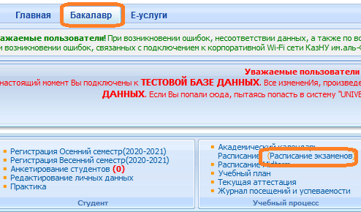

5. For those disciplines for which the exam time has come, the “Start written exam” command will appear (highlighted in red). This means that the student can follow the link and answer the exam questions.

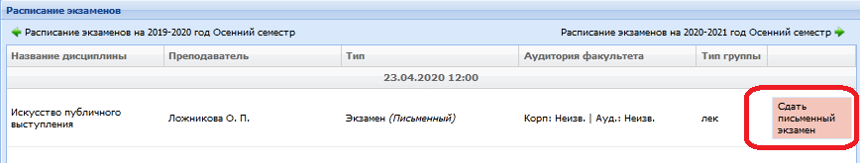
Start written exam function
The student must use the Start Exam feature on his Exam Schedule page.
  - Start written exam function is only active after the start of the exam time.
  - The function to pass the written exam is available to the student during the period of the exam. The set time for the exam is the same for all faculties and specialties.
  - The function to start the written exam is active only for those students who have unclosed final sheets (exam, retake, Incomplete).
  - Start Written Exam function closes when the exam pass time expires.

ATTENTION. In Univer IS, a student cannot attach files. He is obliged to enter his answer in the answer field using the keyboard online. The text answer cannot contain a picture, formula or other special characters.

6. After clicking on the Start written exam link, a window will open where the student will see the questions on his examination paper. The exam lasts exactly 2 hours.

ATTENTION. For faculties of natural sciences and the Higher School of Economics, it is possible to increase the duration of the exam by 1 hour upon submission to the Vice-Rector for Academic Affairs with justification of the reasons for the increase in the duration of the exam (complex input of formulas, etc.).

- After the end of the time, the system will not accept written responses. Therefore, it is recommended to periodically save typed responses on the page until the time expires. The page displays a timer by which the student can navigate in time. If during the exam, the students lost their Internet connection or the student accidentally closed the page, then he must reconnect or re-enter the system by repeating steps 2 to 7. During the exam, the student can return to the system and continue answering his questions.
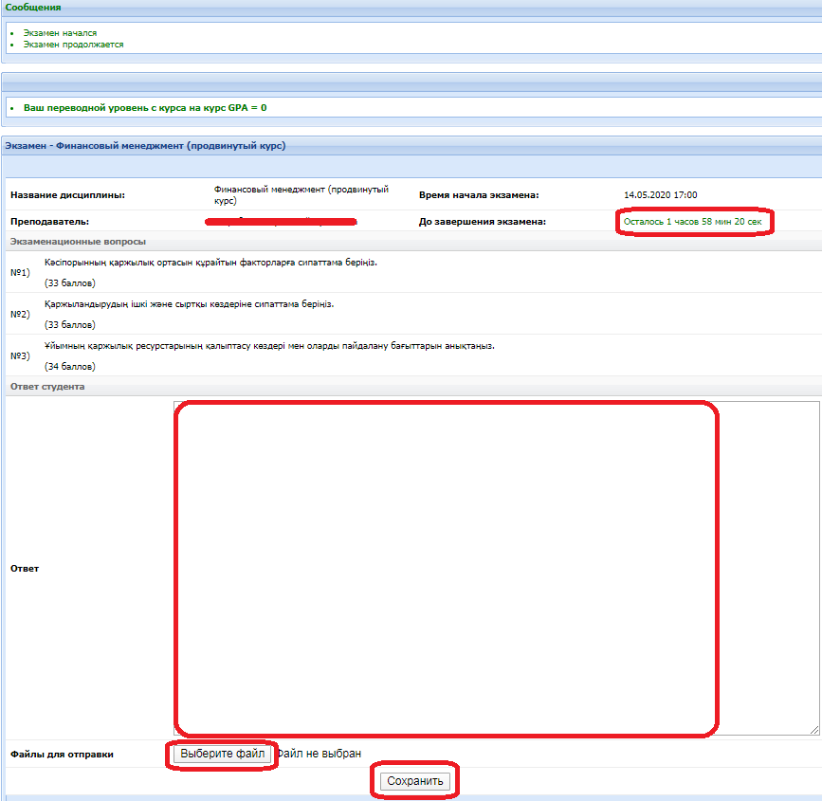
- For your convenience, the System will automatically save your work (text) every 5 minutes.
- You can type answers in a Microsoft Word document and copy and paste this text into the answer field in the UNIVER system.
- On the page for answering ticket questions there is a button - "Save", it is recommended to periodically save the printed answers on the page until the time expires.
- After the answer is saved, the file will be automatically sent to check for borrowings.
8. After completing the exam, your answers will be sent to the examiner for verification, who, after examining the Antiplagiat.ru system report with a detailed analysis of your textual answer, will evaluate your answer to the exam task.
9. Upon completion of the test, the examiner puts marks in the statement and you can see the results of the exam on the page of the current certification.

EXAMINER / LECTURER
1. The examiner on his “Lecturer” page follows the link Certification - Select a statement (examination, retake, Incomplete) - Open a statement - Check written work in the discipline.

2. A list of students included in the list and who completed the written exam in the discipline will open. Lecturer can review the questions on each student's exam paper.
3. To get acquainted with the student's answer to the questions, use the More link.

4. The system provides for the option of checking answers for originality. The check is turned on automatically if the university maintains contact with antiplagiat.ru. To view the full report, click the View link in the Full Antiplagiat report field.

ATTENTION. Analysis of the report on the presence of plagiarism in the written work of students is mandatory.

  - After opening the general summary on the presence of borrowings in the student's work, lecturer can proceed to studying the full report of the student's work in the Antiplagiat.ru system. To do this, click on the button “Go to the page of the Antiplagiat system.” Working in the Antiplagiat system is described in Appendix 4.

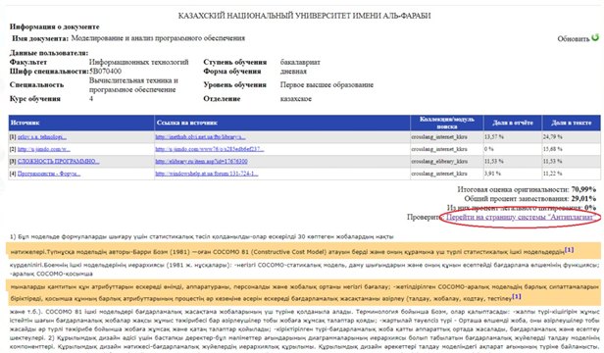

- After recalculating the full report, in order to synchronize the updated data with the report in IS Univer, lecturer must click on the Update button in IS Univer.
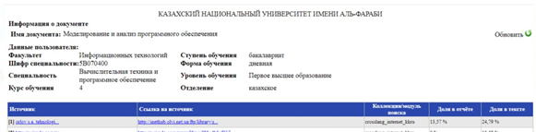

7. Lecturer examines the student's answer and makes a decision on setting the appropriate score, taking into account the level of originality of the work.
8. After checking the student's work, you can put a score in the Grade field and Save it using the button.

The Status field shows the status of the student passing the exam (completed, not started, not completed).

ATTENTION. You cannot start grading student work before the exam is complete! The affixed grades are not automatically transferred to the attestation paper. Lecturer transfers the assigned points to the attestation paper manually.

9. Upon completion of checking the students' answers and putting marks, it will be possible to print the form of the exam results by clicking on the link Distance courses - Open discipline - Print exam results.
(Printout - at the request of the university services or in order for the teacher to conveniently transfer the points to the statement. If not necessary, no need to print).

3. WRITTEN EXAM: PROJECT, CREATIVE TASK.
It is conducted on the Moodle LMS. The exam format is asynchronous.

A project is an independent educational work carried out for a long time. The exam format is suitable for almost all specializations.
The project allows you to assess the ability of students to independently apply their knowledge in the process of solving practical problems and problems, to navigate in the information space and the level of formed analytical, research skills, practical and creative thinking.

Creative task - the format is close to project work. Recommended for students in specialties that require creative thinking, creativity: journalists, philologists, philosophers.
Partially regulated task that has a non-standard solution and allows you to diagnose the ability to integrate knowledge of various fields, to argue your own point of view. It can be performed individually or by a group of students.

CONDITION. To conduct this type of exam, lecturer must distribute in advance the topics of group and (or) individual projects, creative assignments.
Duration - several days or weeks. At the discretion of the teacher.
Due date - according to the exam schedule.

You can learn more about the methodological component of different formats in the methodological instructions for teaching with the use of DET, prepared by the Methodical Work Service, chairmen of methodological councils of faculties.

EXAM PROCEDURE
IMPORTANT - the exam is held on a schedule that must be known in advance by students and teachers. This is the responsibility of the departments and the faculty.

LECTURER
1. Lecturer of a discipline must necessarily prepare a document "Final control of the discipline" in PDF-format, which sets out:
  - rules for conducting the exam;
  - format for presentation of responses;

ATTENTION. It is allowed to upload final REPORTS only in *.docx formats Additional files, if available - images, graphics, listings, etc. depending on the task, can be loaded in the appropriate formats (for this, set the ability to load data files in formats other than docx when creating the “Assignment” element).
The size of uploaded files should not exceed 30 MB. If it is necessary to send large files, students upload files to cloud storage and publish links to them in the text of the report.

  - assessment policy;
  - themes of projects or creative assignments: individual or for groups;
  - schedule (deadlines for assignments);
- composition of the groups (be sure to appoint a web conference organizer in each group who will record the discussion and submit it along with the assignment in the system by publishing a link to the video).

ATTENTION. Inform students about the prerequisite - the faces of all group members should be visible on the video, so that the teacher can assess the activity of each participant when discussing the assignment and consider this during certification.

2. According to the dates established in the disposal (order) on loading examination tasks timings, upload prepared PDF-file to the Moodle LMS for the zero week - it is located at the very beginning of the course - until the first week. To do this, use the element “Assignment” and name it “Final Exam on the Discipline” (see Appendix 2).

BE SURE TO INDICATE THE DEADLINES
3. To do this, set up the Start Date and End Date settings very carefully. (see Appendix 2).
- In the "Start Date" window, set a date that you yourself defined as the start of work on a project or creative assignment (for example, if it is a very complex project, the start date may be a few days or weeks before the exam).
- In the “End Date” window, set the scheduled end date and time of the exam.
On average, 2-3 hours can be allocated for uploading a project work or a creative assignment in the Moodle LMS. That is, at the time allocated by you, students must upload the completed work into the system. After the time expires, the student will not be able to send files.
- The number of attached files DETERMINE YOURSELF depending on the task.
- The maximum total score for all submitted works, if you asked to send several files, is 100 points.
- Configure the check of work by the services Antiplagiat (in case of difficulty, contact INET employees Shynar Smagulova or Anel Mankeeva by phone in the hotline).
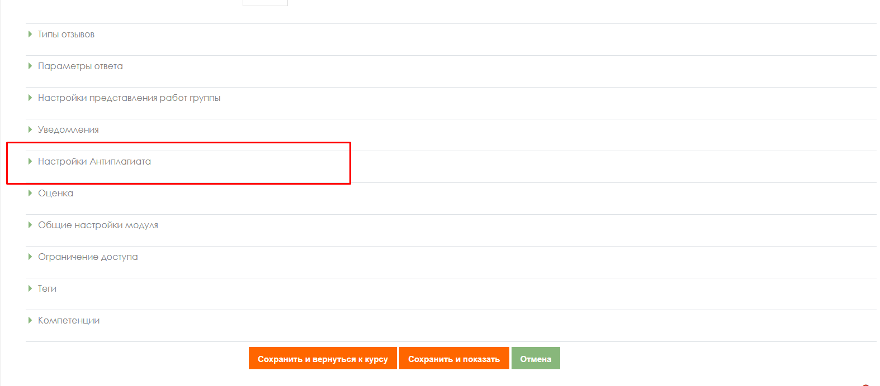
IMPORTANT. Be sure to set the RESTRICTION OF ACCESS to the task!
(see Appendix 2)

4. Inform the students in the general chat where the exam rules and topics of projects or creative assignments are loaded for them.

STUDENTS
1. At the time set by the teacher, they log in to the Moodle LMS and get access to the task "Final exam on the discipline".
2. Look through the lecturer’s assignment.
3. In the case of a group assignment, groups are formed according to the lists specified in the document "Final exam on discipline".
3.1 Participants, when working in a group to complete the assignment, call each other, organize discussions on videoconferencing platforms (Microsoft Teams corporate connections are recommended, in case of technical problems - ZOOM, Skype and others), making a video recording of joint work on a project or creative assignment.
3.2 The student organizer of conferences, who was appointed by the teacher, must organize, record and send, together with the final project through the Moodle LMS, at least 2 videos of the group discussion in the form of a hyperlink specified in the text of the work (video files are uploaded by the student to cloud data storage, a link to a file with a restriction "Access by reference" is indicated in the student's answer file).

If the work is individual, video recording is not required.

4. Carry out the teacher's task
5. Based on the results achieved, they draw up a final report on the work done.
6. According to the schedule of exams (the beginning of the exam is the time of the exam on the schedule, the end is the time of the exam on the schedule + the time set by the teacher to download the answer, about 2-3 hours at the discretion of the teacher), students upload the result of the assignment into the LMS Moodle, for this:
6.1 students are authorized in the LMS Moodle accounts;
6.2 open the element "Final exam on the discipline";
6.3 select the item "Add answer to the task";
6.4 upload their works in the file upload field;
6.5 click "Save", ("Submit for verification"),
6.6, if necessary, checks the work for borrowings using the Antiplagiat system. The student
will be given 1 attempt to check the written report for originality.

IMPORTANT. Be sure to warn students that the postponement of the uploading of finished works in the Moodle LMS is not allowed!

As a result of the exam, the lecturer receives from the students:
1) video recordings of conferences, if this is a joint work (it is sent by the organizer of the video conference, whom you assigned in the group),
2) a completed project or creative work, drawn up in the form of a report and additional files-attachments to the report in *.docx format (if necessary, depending on the assignment) FROM EACH STUDENT.

Example of student report content:
1. Introductory part
- list of the group, with the highlighting of the full name of the author of a specific uploaded document;
- short description of the task - exactly the task at hand, you do not need to copy the entire teacher's document.
2. Main part:
- description of the achieved results of the project (directly solving the task in the form of a report, images, links to videos, diagrams, graphs, etc., depending on the task);
- description of the progress of the project assignment;
- description of the deviations and difficulties encountered in the course of the project, as well as the ways used to overcome them.
3. Teamwork (in the case of group work):
- members of the group:
- describe their personal contribution to the accomplishment of project objectives;
- each student reveals the results achieved by him and their significance for the implementation of the project;
- group captain (responsible for video recording)
- describes his own contribution to the project.
- In addition, the captain's report indicates the work performed by each group member (from the reports of the other group members).
- The description of the work of each student is drawn up in the report in separate chapters or by means of hyperlinks to blocks in the text, which contain a description of the work done by a particular participant.
- The captain should begin the job description for a particular student with that student's last name, first name and patronymic.
- If necessary, the captain leaves comments on the student's work.
4. Conclusion. Conclusions on the work done.
5. References.
  - list of used literature;
  - a description of the methods and technologies used in the project for solving the assigned tasks (programs, tools, links to key regulatory documents, methods).

ATTENTION. EACH student in his report must write the introductory and main parts, conclusion, literature (all the same, in the case of a group project).
In the block of teamwork, each student describes only his own contribution to the solution of the problem posed by the teacher (i.e. this block will be unique in each report), except for the report of the group captain, which should list the achievements of each student.

LECTURER
1. Checks the final work and reports of students.
2. Checks reports of Group capitan for plagiarism in the Antiplagiat.ru system.

IMPORTANT. Checking the examination paper for originality.
Lecturer, based on the Antiplagiat system report, evaluates the main parts of the team captain's report (introductory and main parts, conclusion and literature).
Then, by disabling/enabling the corresponding blocks in the "Sources" list of the report, Antiplagiat recalculates the report, analyzes the chapter for plagiarism separately for each student.
In the case of individual project assignments, the student's report is assessed for plagiarism in full.

3. Based on the results of the check, lecturer certifies the participants of the exam:
- assigns points in the LMS Moodle system;
- transfers the points in the system to the Univer IS attestation paper.
4. Time for scoring in the attestation paper for an exam conducted in the format of a project or creative task - up to 72 hours.

In general:
  - The exam is held on schedule.
  - Students and lecturer must know the date and time of the exam.
  - The term for uploading project themes and creative assignments is at the discretion of the lecturer, and depends on the duration of the work, which the lecturer himself determines for the students.
  - Inform students where you uploaded the assignments and what time frame you have set for
executing and sending an answers.
  - Students should upload the result of the project work or creative assignment into system according to the schedule.
6. On exam day, remind students of the deadlines.
- Checking for originality is a prerequisite.
- It is forbidden to change deadlines at the request of students. The system indicates the changes.
4. WRITTEN EXAM: CASE-TASK.
It is conducted on the Moodle LMS. The exam format is asynchronous.

This is a problematic task in which the trainee is asked to comprehend a real professionally oriented situation necessary to solve a problem. Suitable for all areas of training.

Duration
The exam starts according to the exam schedule. Lecturer determines the end of the exam. It is advisable to provide 2-3 hours in the schedule for this exam format. This is the recommended time. If you need more time or less time, schedule with an appropriate deadline.

Workload
Lecturer determines the volume of the completed case task.

You can learn more about the methodological component of different formats in the methodological instructions for teaching with the use of DET, prepared by the Methodical Work Service, chairmen of methodological councils of faculties.

EXAM PROCEDURE
IMPORTANT - the exam is held on a schedule that must be known in advance by students and teachers. This is the responsibility of the departments and the faculty.

LECTURER
1. Lecturer of a discipline must necessarily prepare a document "Final control of the discipline" in PDF-format, which sets out:
- rules for conducting the exam;
- format for presentation of responses;

ATTENTION. It is allowed to upload final REPORTS only in and *.docx formats Additional files, if available - images, graphics, listings, etc. depending on the task, can be loaded in the appropriate formats (for this, set the ability to load data files in formats other than docx when creating the “Assignment” element).
The size of uploaded files should not exceed 30 MB. If it is necessary to send large files, students upload files to cloud storage and publish links to them in the text of the report.

- assessment policy;
- themes of case tasks: individual or for groups;
- schedule (deadlines for assignments);
- composition of the groups (be sure to appoint a web conference organizer in each group who will record the discussion and submit it along with the assignment in the system by publishing a link to the video).

ATTENTION. Inform students about the prerequisite - the faces of all group members should be visible on the video, so that the teacher can assess the activity of each participant when discussing the assignment and consider this during certification.

2. According to the dates established in the disposal (order) on loading examination tasks timings, upload prepared PDF-file to the Moodle LMS for the zero week - it is located at the very beginning of the course - until the first week. To do this, use the element “Assignment” and name it “Final Exam on the Discipline” (see Appendix 2).

BE SURE TO INDICATE THE DEADLINES
3. To do this, set up the Start Date and End Date settings very carefully. (see Appendix 2).
- In the "Start Date" window, set a date that you yourself defined as the start of work on a project or creative assignment (for example, if it is a very complex project, the start date may be a few days or weeks before the exam).
- In the “End Date” window, set the scheduled end date and time of the exam.
On average, 2-3 hours can be allocated for uploading a project work or a creative assignment in the Moodle LMS. That is, at the time allocated by you, students must upload the completed work into the system. After the time expires, the student will not be able to send files.
- The number of attached files DETERMINE YOURSELF depending on the task.
- The maximum total score for all submitted works, if you asked to send several files, is 100 points.
- Configure the check of work by the services Antiplagiat (in case of difficulty, contact INET employees Shynar Smagulova or Anel Mankeeva by phone in the hotline).

IMPORTANT. Be sure to set the RESTRICTION OF ACCESS to the task!
(see Appendix 2)

4. Inform the students in the general chat where the exam rules and topics of projects or creative assignments are loaded for them.

STUDENTS
1. At the time set by the teacher, they log in to the Moodle LMS and get access to the task "Final exam on the discipline".
2. Look throught the lecturer’s assignment.
3. In the case of a group assignment, groups are formed according to the lists specified in the document "Final exam on discipline".
3.1 Participants, when working in a group to complete the assignment, call each other, organize discussions on videoconferencing platforms (Microsoft Teams corporate connections are recommended, in case of technical problems - ZOOM, Skype and others), making a video recording of joint work on a case-tasks.
3.2 The student organizer of conferences, who was appointed by the teacher, must organize, record and send, together with the final project through the Moodle LMS, at least 2 videos of the group discussion in the form of a hyperlink specified in the text of the work (video files are uploaded by the student to cloud data storage, a link to a file with a restriction "Access by reference" is indicated in the student's answer file).

If the work is individual, video recording is not required.

4. Carry out the teacher's task
5. Based on the results achieved, they draw up a final report on the work done.
6. According to the schedule of exams (the beginning of the exam is the time of the exam on the schedule, the end is the time of the exam on the schedule + the time set by the teacher to download the answer, about 2-3 hours at the discretion of the teacher), students upload the result of the assignment into the LMS Moodle, for this :
6.1 students are authorized in the LMS Moodle accounts;
6.2 open the element "Final exam on the discipline";
6.3 select the item "Add answer to the task";
6.4 upload their works in the file upload field;
6.5 click "Save", ("Submit for verification"),
6.6 if necessary, checks the work for borrowings using the Antiplagiat system. The student
will be given 1 attempt to check the written report for originality.

IMPORTANT. Be sure to warn students that the postponement of the uploading of finished works in the Moodle LMS is not allowed!

As a result of the exam, the lecturer receives from the students:
1) video recordings of conferences, if this is a joint work (it is sent by the organizer of the video conference, whom you assigned in the group),
2) a completed answer to a case task, drawn up in the form of a report and additional files-attachments to the report in *.docx format (if necessary, depending on the assignment) FROM EACH STUDENT.

Example of student report content:
1. Introductory part
- list of the group, with the highlighting of the full name of the author of a specific uploaded document;
- short description of the case task - exactly the task at hand, you do not need to copy the entire teacher's document.
2. Main part:
- description of the achieved results of the case (directly solving the task in the form of a report, images, links to videos, diagrams, graphs, etc., depending on the task);
- description of the progress of the case assignment;
- description of the deviations and difficulties encountered in the course of the case-task, as well as the ways used to overcome them.
3. Teamwork (in the case of group work):
members of the group:
  - describe their personal contribution to the accomplishment of case objectives;
  - each student reveals the results achieved by him and their significance for the implementation of the project;
group captain (responsible for video recording)
  - describes his own contribution to the project.
- In addition, the captain's report indicates the work performed by each group member (from the reports of the other group members).
- The description of the work of each student is drawn up in the report in separate chapters or by means of hyperlinks to blocks in the text, which contain a description of the work done by a particular participant.
- The captain should begin the job description for a particular student with that student's last name, first name and patronymic.
- If necessary, the captain leaves comments on the student's work.
4. Conclusion. Conclusions on the work done.
5. References.
  - list of used literature;
  - a description of the methods and technologies used in the case for solving the assigned tasks (programs, tools, links to key regulatory documents, methods).

ATTENTION. EACH student in his report must write the introductory and main parts, conclusion, literature (all the same, in the case of a group project).
In the block of teamwork, each student describes only his own contribution to the solution of the problem posed by the teacher (i.e. this block will be unique in each report), except for the report of the group captain, which should list the achievements of each student.

LECTURER
1. Checks the final work and reports of students.
2. Checks reports for plagiarism in the Antiplagiat.ru system (required).

IMPORTANT. Checking the examination paper for originality.
The teacher, based on the Antiplagiat system report, evaluates the main parts of the team captain's report (introductory and main parts, conclusion and literature).
Then, by disabling/enabling the corresponding blocks in the "Sources" list of the report, Antiplagiat recalculates the report, analyzes the chapter for plagiarism separately for each student.
In the case of individual project assignments, the student's report is assessed for plagiarism in full.

3. Based on the results of the check, lecturer certifies the participants of the exam:
- assigns points in the LMS Moodle system;
- transfers the points in the system to the Univer IS attestation paper.
4. Time for scoring in the attestation paper for an exam conducted in the format of a project or creative task - up to 72 hours.

In general:
- The exam is held on schedule.
- Students and lecturer must know the date and time of the exam.
- The term for uploading project themes and creative assignments is at the discretion of the lecturer, and depends on the duration of the work, which the lecturer himself determines for the students.
- Inform students where you uploaded the assignments and what period you have set for executing and sending answers.
- Students should upload the result of case-tasks completion into system according to the schedule.
- On exam day, remind students of the deadlines.
- Checking for originality is a prerequisite.
- It is forbidden to change deadlines at the request of students. The system indicates the changes.

5. WRITTEN EXAM: ESSAY.
It is conducted on the Moodle LMS. The exam format is asynchronous.
An essay is a means of monitoring the ability of students to work with information, its analysis, structuring, and the formation of conclusions and recommendations. It is also called the "Thinking" exam. This type of exam involves students writing one large text on a specific problem for three hours.
Students are expected to contemplate, sketch, and structure their essays over a period of one hour. Then they write for two hours. This exam format requires you to put together many different course elements using your brains and your analytical skills.
It should be noted that for western universities, writing an essay for an exam is a completely traditional type of exam, Essays in exams or Critical Thinking exam.

You can learn more about the methodological component of different formats in the methodological instructions for teaching with the use of DET, prepared by the Methodical Work Service, chairmen of methodological councils of faculties.
.
Duration
The exam starts according to the exam schedule. The end of the exam is determined by the teacher. It is advisable to provide 2-3 hours in the schedule for this exam format. This is the recommended time. If you need more time, schedule with an appropriate deadline.
The duration of the exam and the limitation on the maximum number of characters in the essay, depending on the level of education (bachelor's, master's, doctoral studies), is established by the methodological council of the faculty.

EXAM PROCEDURE
IMPORTANT - the exam is held on a schedule that must be known in advance by students and teachers. This is the responsibility of the departments and the faculty.

LECTURER
1. Lecturer of a discipline must necessarily prepare a document "Final control of the discipline" in PDF-format, which sets out:
- rules for conducting the exam;
- format for presentation of responses;

ATTENTION. It is allowed to upload final REPORTS only in *.docx formats Additional files, if available - images, graphics, listings, etc. depending on the task, can be loaded in the appropriate formats (for this, set the ability to load data files in formats other than docx when creating the “Assignment” element).
The size of uploaded files should not exceed 30 MB. If it is necessary to send large files, students upload files to cloud storage and publish links to them in the text of the report.

- assessment policy;
- themes of essays;
- schedule (deadlines for assignments);
2. According to the dates established in the disposal (order) on loading examination tasks timings, upload prepared PDF-file to the Moodle LMS for the zero week - it is located at the very beginning of the course - until the first week. To do this, use the element “Assignment” and name it “Final Exam on the Discipline” (see Appendix 2).

BE SURE TO INDICATE THE DEADLINES
3. To do this, set up the Start Date and End Date settings very carefully. (see Appendix 2).
- In the "Start Date" window, set a date that you yourself defined as the start of work on a project or creative assignment (for example, if it is a very complex project, the start date may be a few days or weeks before the exam).
- In the “End Date” window, set the scheduled end date and time of the exam.
On average, 2-3 hours can be allocated for uploading a project work or a creative assignment in the Moodle LMS. That is, at the time allocated by you, students must upload the completed work into the system. After the time expires, the student will not be able to send files.
- The number of attached files DETERMINE YOURSELF depending on the task.
- The maximum total score for all submitted works, if you asked to send several files, is 100 points.
- Configure the check of work by the services Antiplagiat (in case of difficulty, contact INET employees Shynar Smagulova or Anel Mankeeva by phone in the hotline).

IMPORTANT. Be sure to set the RESTRICTION OF ACCESS to the task!
(see Appendix 2)

4. Inform the students in the general chat where the exam rules and topics of projects or creative assignments are loaded for them.

STUDENTS
1. At the time set by the teacher, they log in to the Moodle LMS and get access to the task "Final exam on the discipline".
2. Look throught the lecturer’s assignment.
3. Carry out the teacher's task
4. Based on the results achieved, they draw up a final answer - essay.
4.1 students are authorized in the LMS Moodle accounts;
4.2 open the element "Final exam on the discipline";
4.3 select the item "Add answer to the task";
4.4 upload their works in the file upload field;
4.5 click "Save", ("Submit for verification").

IMPORTANT. Be sure to warn students that the postponement of the uploading of finished works in the Moodle LMS is not allowed!

LECTURER
1. As a result of the exam, lecturer receives an essay from students in the form of a document *.docx.
2. Examines the final work of students.
3. Checks reports for plagiarism in the Antiplagiat.ru system (required) and Strikeplagiarism (optional, in case of controversial issues and/or the need to obtain additional information about possible primary sources of plagiarism).
4. Based on the results of the check, the teacher certifies the participants of the exam:
- assigns points in the Moodle LMS system;
- transfers the points in the system to the Univer IS attestation paper.
5. Time for setting points in the attestation paper for an exam conducted in an essay format - up to 72 hours.

In general:
1. The exam is held on schedule.
2. Students and the teacher must know in advance the date and time of the exam.
3. Be sure to set the timing of the exam in accordance with the schedule. If the schedule does not indicate the end date for the exam, determine it yourself.
4. No later than 30 minutes in advance remind students of the start of the exam and notify of deadlines.
5. Checking for originality is a prerequisite.
6. It is forbidden to change deadlines at the request of students. The system indicates changes.

6. EXAM - TESTING
It is conducted on Univer IS and LMS Moodle. The exam format is synchronous.

Testing is carried out:
- in Univer IS - for large groups of more than 50 people;
- in Moodle LMS - for small groups up to 50 people.

It is FORBIDDEN to conduct exam testing on external services (Kahoot, Quizzlet, etc.). External services can be used during the current class, but not for the exam.
Exam testing is carried out only on the official information and educational platforms of the university: in Univer IS or Moodle LMS.

Testing control - online proctoring.

Proctoring technology ("proctor" - to control the course of the exam). The proctors, as in the usual exam in the classroom, make sure that the examinees pass the test honestly: they complete the assignments on their own and do not use additional materials. Both a specialist (full-time proctoring) and a program that controls the test subject's desktop, the number of faces in the frame, extraneous sounds or voices, and even gaze movements (cyber proctoring) can monitor the online exam in real time via a webcam. Mixed proctoring vi is often used: the video of the exam with the notes of the program is additionally watched by a person and decides whether violations have actually taken place.

Test duration:

in Univer IS - 90 minutes for 40 questions,

in Moodle LMS - 60 minutes for 25 questions, 1 attempt (timing and number of attempts are set manually by the teacher when loading tests).

ATTENTION. IT IS FORBIDDEN to change the test settings after being checked by INET employees! All changes made by the teacher are tracked by the system. The exam can be canceled if violations are found on the part of teachers.

You can learn more about the methodological component of different formats in the methodological instructions for teaching with the use of DET, prepared by the Methodical Work Service, chairmen of methodological councils of faculties.

EXAM PROCEDURE
IMPORTANT - the exam is held on a schedule that must be known in advance by students and teachers. This is the responsibility of the departments and the faculty.

LECTURER
Develop test questions in accordance with the requirements of the selected system.
UNIVER IS
  - 150-200 questions, excluding credits;
  - from 1 or more (1-3) correct answers at the discretion of the lecturer.
A set of prepared tests is drawn up in accordance with Appendix 3 and sent no later than 04/15/2021 to the Head of the Testing Department Aigul Gabdullaevna Baynoserova to the email address: Aigul.Bainoserova@kaznu.kz.

IMPORTANT. If there is a ready-made and uploaded set of questions on a discipline in IS Univer (disciplines of VOUD), lecturer have to contacts the testing department.

Moodle LMS
25-100 questions:
1 credit (ECTS) = 25 questions;
2.3 credits (ECTS) = 50 questions;
4.5 credits (ECTS) = 75 questions;
6,7,8 credits (ECTS) = 100 questions.
The teacher creates an element "Quiz" in the Moodle LMS and fills it in with questions that he manually added to the question bank (Appendix 1).
When creating a test, at least 4 types of questions must be used in equal proportions in 1 test set (for example, 6 multiple choice + 6 true/false + 6 short text + 7 for compliance = 25).
Tests must be created, configured and completed with questions no later than 04/15/2021.
In case of technical difficulties, contact INET staff Shynar Smagulova or Anel Mankeeva by calling the hotline).

- According to the dates established in the disposal (order) on loading examination tasks timings, upload prepared PDF-file (depending on the system in which you organize testing) “Final exam rules. Testing" in PDF format:
- in Univer IS, in the tab “Program of the final exam in the discipline”;
- in Moodle LMS - at the very beginning of the course, at week zero. To do this, use the "File" element.
The document must contain:
- rules for the exam (be sure to inform students that they should study the instructions for proctoring in Univer IS and Moodle LMS);
- assessment policy;
- schedule of the exam;
- the number of test questions;
- duration of the exam.
In the rules, be sure to inform about the condition - 30 minutes before the start, students must prepare for the exam in accordance with the requirements of the proctoring instruction.
2. Lecturer creates an element "Test" in the LMS Moodle and fills in it using a random selection of questions by the system from the bank of questions. When creating a test, at least 4 types of questions must be used in equal proportions in 1 test set (for example, 6 multiple choice + 6 true / false + 6 text + 7 for compliance = 25).

IMPORTANT. Please note that in LMS Moodle "Multiple choice" questions with one correct answer and several correct answers are counted as one type of questions.
2.1 After creating the "Test" element, you need to create question categories in the question bank, for this, select the "Question bank" item in the settings menu.

2.2. Open the "Categories" tab
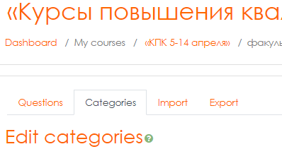
2.3. Scroll down the page and enter the name of the category in the "Name" field and click "Add category" to save. Repeat this operation for each category.
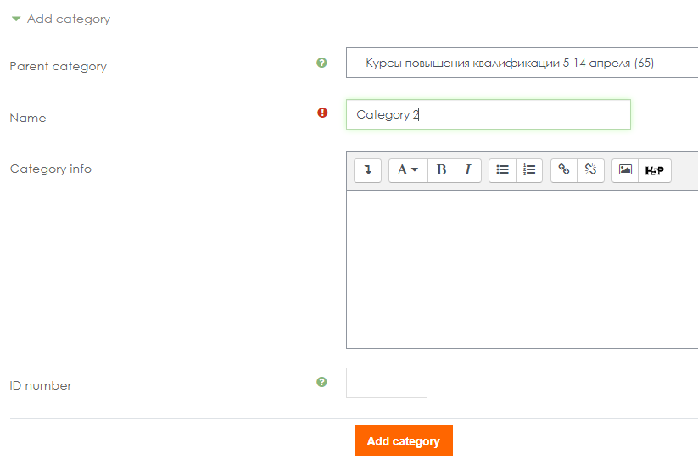

As a result, you will have at least 4 categories:
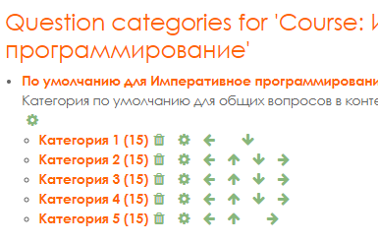

2.4. Click on the category name to enter and fill in the category with questions
("Create a new question") of the same kind. The number of questions (displayed in brackets to the left of the category name) depends on the required total number of questions in the bank and the number of categories. For example, 100 questions are 5 categories of 20 questions in one category.

Note. If you previously filled out the bank of questions without dividing into categories, then in order to divide the questions you need to mark the same type of questions (put a checkbox) and go down the page to select “Move to” indicating the appropriate category.

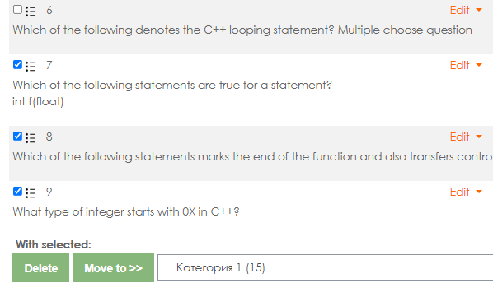

Note. For your test to work correctly there must be at least 10 questions in each category.

2.5. After filling in all the categories with questions, return to the "Test" element and select "Edit Quiz".

2.6. On the test page that opens, select "Add" - "a random question".

2.7. Select the category and the number of questions that will be randomly selected by the system and added to the test for students. To add questions to the test, click "Add random question".

Repeat this step for each of your categories so that in the end there are 25 questions in the test with equal division into categories (for example, for 4 categories: 6 - from the first, 7 - from the second, 7 - thirds, 5 - fourth). The current number of questions in the test is displayed in the upper left corner.
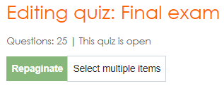

2.8. Edit the number of points for the correct answer - click on the pencil symbol to the right of the points window, set 4 points (for each question). Press “Enter” to save the changes.

2.9. Make sure that the Total score field displays 100 points (in case of an error, repeat step 2.8). Also set 100 in the Maximum rating field and click "Save"
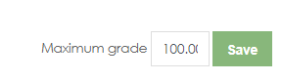

3. After uploading the Rules to the system, in the chat of the messenger, inform the students in which system they can familiarize themselves with the “Final exam rules. Testing”: in Univer IS or in Moodle LMS.
4. Be sure to ask each student to confirm in the chat that they have read the schedule, rules, and requirements of the proctoring instruction.
5. On the scheduled exam day, remind students of the exam.
6. At the end of the testing time, evaluate the student scoresheet and save the scores on the attestation paper:
  - in Univer IS - scores are automatically transferred to the examination sheet. Before saving, carefully check that all students have scores. DO NOT save the statement without checking the completion of points! Save the checked sheet.
  - in Moodle LMS - the score is reflected in the Moodle system scorebook for the created element "Quiz" immediately after testing. Lecturer have to manually transfer the score to the attestation paper in Univer IS. Before saving, carefully check that all students have scores. DO NOT save the statement without checking the completion of points! Save the checked sheet.

ATTENTION. If it is necessary to additionally check the students' answers in the Moodle LMS and to correct the final score (for example, if a student makes a typo when answering a question of the "Short answer" type), the teacher should contact the INET specialists. It is FORBIDDEN to open the test and correct comment on the student answers on your own.
Time for scoring is up to 48 hours. It is possible to revise the duration according to the decision of the Department of Academic Issues.

Test results can be revised based on proctoring results. If a student violated the rules for passing the test, his result will be canceled.

Regulations for organizing video recording of testing in Moodle LMS in the absence of proctoring for groups of up to 20 students

  - Recording and control of passing the exam (proctoring) is carried out by lecturer.
  - Information about the presence/absence of proctoring in the Moodle LMS is displayed below the "Test" element created by lecturer.
  - Lecturer plans a conference / meeting on one of the selected services (MS Teams, Zoom, Skype) and publishes links to connect to the conference in the appropriate section of IS Univer.

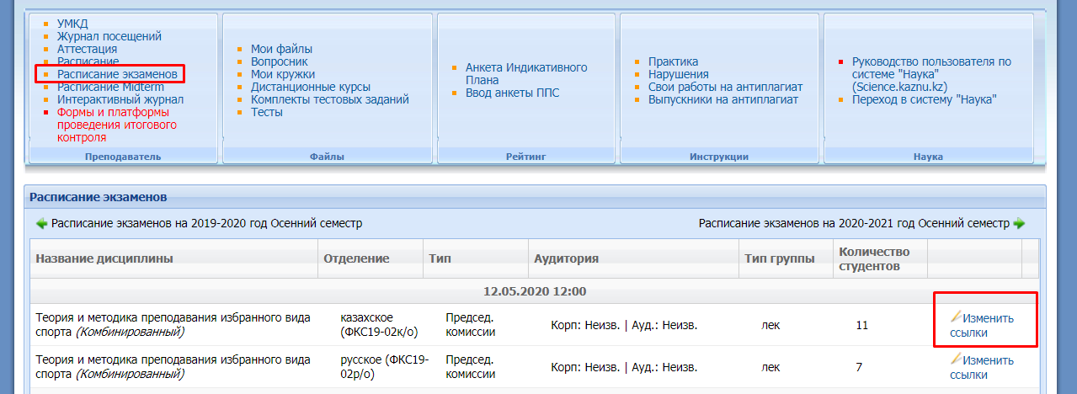
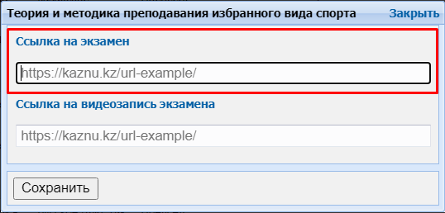

ATTENTION. In the case of a change in the platform and/or a link to a video conference, it is imperative that students be notified of the changes in advance (no later than a day before the exam).

  - Before the start of the exams (10 minutes) on the exam schedule, the exam conference organizer, starts the conference on Microsoft Teams or other video conferencing services and launches the exam participants.

  - After all participants are connected to the conference online, lecturer:
- includes a VIDEO RECORD of the exam;
- welcomes the participants to the exam;
- warns that video is being recorded;
- asks each examinee to turn on the video and audio link, as well as to show on the video camera the original identification document (identity card or passport). It is FORBIDDEN to take an exam on an ID-card and on a photocopy of documents, as well as the room in which it is located - there should be no strangers in the room, additional sources of information (if possible from the student's side);
- warns about the prohibition of the use of additional sources of information and headphones.
  - After completing the organizational activities, the student begins the procedure for passing the exam by logging into the Moodle LMS.
  - In order to control the passing of the exam, during testing, lecturer monitors compliance with the rules of the exam and periodically asks students to turn on the demonstration of their screen.
  - After completing the test, the student can leave the video conference by notifying lecturer.
- After the exam, the teacher uploads a video recording of the course of the exam to a cloud storage service or video hosting (Google Drive, OneDrive, YouTube, etc.) and places a link in the appropriate section of IS Univer.

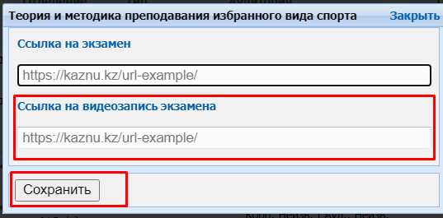

Test results can be revised based on proctoring results. If the student violated the rules for passing the test, his result will be canceled.

7. ORAL EXAMINATION: TRADITIONAL - ANSWERS TO QUESTIONS.
The exam format is synchronous.
It is conducted on BigBlueButton Moodle LMS
or on the al-Farabi KazNU Microsoft Teams corporate platform

The process of passing an oral exam by a student involves the automatic creation of an examination paper, to which the student must answer orally to the examination committee. During the answer, video recording is mandatory.

If it is necessary to visually demonstrate information related to the answer to the ticket's questions (graphs, tables, diagrams, etc.), at the request of lecturer, student must use a screen demonstration or additional tools that allow this action (virtual board, camera, etc.).

According to the approved submission addressed to the member of the board - the vice-rector for academic affairs, students are allowed to use auxiliary resources (draft, programs, calculator, etc.) for answering. In this case, the student must demonstrate the auxiliary resources on camera before and after working with them.

ATTENTION! The use of headphones, including wireless ones, is permitted only at the time of receiving additional questions from the members of the examination committee during the oral examination. In all other cases, the use of headphones is FORBIDDEN.

ATTENTION! In case of technical problems with the display or generation of tickets in the IS UNIVER, the preparation and issuance of tickets manually is PROHIBITED!
In case of technical problems, you should contact the IITiIR support department +7 (727) 377 33 33 (ext. 1142).

The oral exam is conducted:
- Microsoft Teams corporate connection is recommended;
- BigBlueButton service in Moodle LMS is recommended;
- in case of technical problems, external resources ZOOM, Skype, and others.

NOTE. When using Zoom (40 minutes limited), it is recommended that you schedule one student meeting and restart each time after one student has finished answering. Do not start receiving the next student's answer if the current conference time ends.

Exam control
Lecturer or examination board:
- conducts a video recording of the exam,
- uploads a video recording of the examination progress to a cloud storage service or video hosting (Google Drive, OneDrive, YouTube, etc.), provides open access via a link and places a link in the appropriate section of IS Univer.

Duration
Preparation time is decided by lecturer or the examination committee.
The response time is decided by lecturer or the examination committee. Recommended 15-20
minutes to answer all questions.

EXAM PROCEDURE
IMPORTANT - the exam is held on a schedule that must be known in advance by students and teachers. This is the responsibility of the departments and the faculty.

LECTURER
Uploads the developed examination questions to the Univer IS questionnaire (univer.kaznu.kz).

DEPUTY DECAN
Generates exam papers for certain disciplinary groups on its page. When generating, you can specify the entire list of students in the group, or selectively specify students (for retaking).
- When generating, the number of tickets must be greater than the number of selected students.
- Generation should take place within the discipline group indicated in the exam schedule.
- Generation is only possible before the date and time of the exam. In case of re-generation for students who retake, it is necessary to change the date and time of the group in the exam schedule again.

LECTURER
1. Uploads in the Univer IS, in the "Program of the final exam in the discipline" tab, the document "Final exam on the discipline" ... " in PDF format, which should contain:
- rules for conducting the exam;
- assessment policy;
- schedule of the exam;
- exam platform and link to scheduled exam video conferencing.

IMPORTANT. It is forbidden to publish exam questions. Only the final exam program is presented.

- Lecturer informs the students where the rules of the final exam are located after the date of the exam is set in the schedule.
- Lecturer plans a conference / meeting on one of the selected services (MS Teams, Zoom, Skype) and publishes links to connect to the conference in the appropriate section of IS Univer.

- In the case of a change in the platform and/or a link to a video conference, it is imperative that students be notified of the changes in advance (no later than a day before the exam).

- According to the exam schedule, the organizer of the exam-conference starts a conference at Microsoft Teams or BigBlueButton in Moodle LMS (or other videoconferencing services) and launches the exam participants.

IMPORTANT. In case the exam is accepted by the examination committee, lecturer includes the members of the committee in the chat of the group of students in advance, so that the examiners can also remind students of the beginning of the exam in the general chat.

- After connecting all the participants online in the conference, lecturer or member of the commission:
a. turn on a VIDEO RECORDING of the exam;
b. greets the participants of the exam;
c. warns that video is being recorded;
d. announces the rules of the exam:
- the order of the examinees;
- preparation time;
- response time;
- gives permission to write the theses of the answers, if necessary, on paper;
- warns that the examinee will have to show the abstract sheet before starting the answer;
- allows other examinees to be on standby — not be in front of the camera all the time, but not leave the meeting;
e. announces the surname, name and patronymic of the examinee;
f. asks the examinee to show on a video camera an identity document (or passport. IT IS FORBIDDEN to take exam with an student-ID card exam) the room in which he is located - there should be no strangers in the room, additional sources of information (if it ispossible from the student's side);
g. warns of a prohibition on the use of additional sources of information.
- The chairman of the examination committee calls the full name of the student, asks him to turn on the screen demonstration, log into the Univer IS with his account, open the exam paper and read the questions.
- The committee records the questions posed by the student for later questioning.
- Asks the student to switch the image to the camera (it is imperative that the student's face is visible)
- Allows time to prepare an answer:
- the time for preparation is determined by the teacher and/or members of the commission;
- members of the commission and the teacher control the process of preparing the student by making comments if necessary or stop the student's response (in case of gross violations of the rules of conduct on the exam, with the preparation of an act of violation);
- students are allowed to use a draft to compose a summary of the answer. In this case, the student must demonstrate to the camera a draft paper before and after working with it.
- Conducts a student survey on exam questions.
- After completing the student's answer, allows the examiner to leave the videoconference.
- Then the procedure is repeated with each student of the group.
- Upon completion of all student answers or an individual student, if the Zoom program is used with a limit of 40 minutes, stops the video recording.

STUDENTS
- Before starting the oral examination, students have to check:
- Internet connection on working device (computer, laptop, tablet), the device must be provided with charging during the entire exam time;
- serviceability of the web camera and microphone.

  - 30 minutes before the start of the exam, ALL students of the group enter the video conference room organized by the lecturer or members of the commission according to the link specified in the rules of the final exam (sent by the lecturer/members of the commission in case of a violation of the video communication service).
  - 30 minutes before the start of the exam, check the possibility of entering the univer.kaznu.kz system through any browser, but preferably through Google Chrome (in case of losing the login and/or password, the student must contact the curator-advisor before the start of the exam). After verification, they log out of the account pending an invitation from the commission.

ATTENTION. A STUDENT DOES NOT HAVE THE RIGHT TO OPEN AN EXAM PAPER UNTIL AN INDIVIDUAL INVITATION BY THE COMMISSION FOR THE EXAMINATION. ONLY AT THE REQUEST OF THE COMMISSION, THE STUDENT LOGS INTO THE UNIVER IS ACCOUNT, AND OPENS THEIR TICKET ON VIDEO RECORDING.

- When the time comes for the exam, the student who is called by the committee shows his ID on camera.
- Enables screen sharing.
- Logs into account in Univer IS goes to the "Exam Schedule" page selects the current exam - by clicking on the "Pass oral exam" button.
- The function "Pass oral exam" is active only after the start of the exam time;
- The "Pass oral exam" function is active only for those students who have unclosed final exam (exam, retake, Incomplete).
- After clicking on the link “Pass oral exam” a window will open where the student will see the questions of his examination paper.
- The student shows the screen with the exam paper questions, reads them out loud.
- Transfers the video conferencing service display to the camera and prepares for a response.
- After completing his answer, leaves the video conference room.

IMPORTANT. It is forbidden to publish exam papers before the start of the exam on any platform and send it to students.

If ZOOM is used for technical reasons, the examiner must schedule the exam over periods of 30-40 minutes to reconnect. The student must complete the exam in one session. It is prohibited to start responding in one session and end after the reconnection.
ATTENTION. If for technical reasons (power outage, disconnection or low Internet speed) a student who has already opened his ticket is absent from the online exam for more than 10 minutes, then his answer will be canceled. The exam is postponed to another date in agreement with the Department of Academic Affairs.

IMPORTANT. The video recording is turned off only at the end of the exam, when the answers of all examinees have been accepted.

ON THE RESULTS OF THE EXAM:
1. The examination committee and the lecturer certify the participants of the exam.
2. Put points in the attestation paper in Univer IS.
Time for scoring on the oral exam - 48 hours. Time for setting points in the attestation sheet for the oral exam is 48 hours. It is possible to revise the duration by the decision of the Department of Academic Affairs.

3. Uploads a video recording of the examination progress to a cloud storage service or video hosting (Google Drive, OneDrive, YouTube, etc.) and places a link in the appropriate section of IS Univer.
In general:
  - The exam is held on schedule.
  - Students and lecturer must know in advance the date and time of the exam.
  - It is obligatory to place in Univer IS document "Final exam on the discipline".
  - The chairman of the examination committee and the students are connected by video link in advance before the start of the exam.
  - The chairman of the examination committee includes a VIDEO RECORDING of the exam.
  - Students at the beginning of the exam according to the schedule get access to the tickets generated by the Univer IS in their univer.kaznu.kz accounts.

STUDENTS DOES NOT HAVE THE RIGHT TO OPEN AN EXAM PAER UNTIL AN INDIVIDUAL INVITATION BY THE COMMISSION. ONLY AT THE REQUEST OF THE COMMISSION, THE STUDENT LOGS INTO THE UNIVER IS ACCOUNT, AND OPENS HIS TICKET UNDER ON VIDEO RECORDING.

  - The student, confirms his identity, demonstrates his exam paper in Univer IS, and after preparation for a period of time set by the teacher or the commission, answers the questions.
  - While the student answers, other group members can go into standby mode (turn off the cameras but not leave the videoconferencing service).
- After the commission accepts the student's answer, he can leave the video conference room.
- The video recording is turned off only at the end of the exam, when the answers of all examinees have been accepted.
- Within 48 hours, the points scored by students must be transferred into attestation paper.

8. COMBINED EXAM №1:
written draft followed by oral defense

Held at Moodle LMS
The exam format is hybrid

A project is an independent educational work carried out for a long time. The exam format is suitable for almost all specializations.
The project allows you to assess the ability of students to independently apply their knowledge in the process of solving practical problems and problems, navigate in the information space and the level of formed analytical, research skills, practical and creative thinking.

EXAM PROCEDURE

The exam consists of two parts: written (project implementation, implementation report) and oral (project defense).
- The written part of the project is carried out within the timeframe assigned by the teacher in the Moodle LMS. Deadline - 24 hours before the start of the oral part of the exam.
- The oral part of the exam will be held at the time specified in the exam schedule.

LECTURER
  - Lecturer of a discipline must necessarily prepare a document "Final control of the discipline" in PDF-format, which sets out:
- rules for conducting the exam;
- assessment policy;
- format for presentation of responses;
- topics of assignments: individual or for groups;
- schedule (deadlines for assignments);
- groups composition (be sure to appoint a web conference organizer in each group who will record the discussion and submit it along with the assignment in the system by publishing a link to the video).

ATTENTION. In the document "Final exam in the discipline", be sure to indicate the assessment rules - what percentage of the assessment is allocated to the written part (assessment of the report) and what percentage to the oral defense of students.
ATTENTION. Inform about the prerequisite - the faces of all group members should be visible on the video, so that the teacher can assess the activity of each participant when discussing the assignment and take this into account when attestation.

  - According to the dates established in the disposal (order) on loading examination tasks timings, upload prepared PDF-file to the Moodle LMS for the zero week - it is located at the very beginning of the course - until the first week. To do this, use the element “Assignment” and name it “Final Exam on the Discipline”.

BE SURE TO INDICATE THE DEADLINES
3. To do this, set up the Start Date and End Date settings very carefully. (see Appendix 2).
- In the "Start Date" window, set a date that you yourself defined as the start of work on a project or creative assignment (for example, if it is a very complex project, the start date may be a few days or weeks before the exam).

- In the “End Date” window, set the scheduled end date and time of the exam.
On average, 2-3 hours can be allocated for uploading a project work or a creative assignment in the Moodle LMS. That is, at the time allocated by you, students must upload the completed work into the system. After the time expires, the student will not be able to send files.
- The number of attached files DETERMINE YOURSELF depending on the task.
- The maximum total score for all submitted works, if you asked to send several files, is 100 points.
- Configure the check of work by the services Antiplagiat (in case of difficulty, contact INET employees Shynar Smagulova or Anel Mankeeva by phone in the hotline).

IMPORTANT. Be sure to set the RESTRICTION OF ACCESS to the task!
(see Appendix 2)

4. Inform the students in the general chat where the exam rules and topics of projects or creative assignments are loaded for them.

1 part. WRITTEN
STUDENTS

1. At the time set by the teacher, they log in to the Moodle LMS and get access to the task "Final exam on the discipline".
2. Look through the lecturer’s assignment.
3. In the case of a group assignment, groups are formed according to the lists specified in the document "Final exam on discipline".
3.1 Participants, when working in a group to complete the assignment, call each other, organize discussions on videoconferencing platforms (Microsoft Teams corporate connections are recommended, in case of technical problems - ZOOM, Skype and others), making a video recording of joint work on a case-tasks.
3.2 The student organizer of conferences, who was appointed by the teacher, must organize, record and send, together with the final project through the Moodle LMS, at least 2 videos of the group discussion in the form of a hyperlink specified in the text of the work (video files are uploaded by the student to cloud data storage, a link to a file with a restriction "Access by reference" is indicated in the student's answer file).

If the work is individual, video recording is not required.

4. Carry out the teacher's task
5. Based on the results achieved, they draw up a final report on the work done.

6. According to the schedule of exams (the beginning of the exam is the time of the exam on the schedule, the end is the time of the exam on the schedule + the time set by the teacher to download the answer, about 2-3 hours at the discretion of the teacher), students upload the result of the assignment into the LMS Moodle, for this:
6.1 students are authorized in the LMS Moodle accounts;
6.2 open the element "Final exam on the discipline";
6.3 select the item "Add answer to the task";
6.4 upload their works in the file upload field;
6.5 clicks "Save", ("Submit for verification"),
6.6 if necessary, checks the work for borrowings using the Antiplagiat system. The student
will be given 1 attempt to check the written report for originality.

ATTENTION. It is allowed to upload final REPORTS only in *.docx formats Additional files, if available - images, graphics, listings, etc. depending on the task, can be loaded in the appropriate formats (for this, set the ability to load data files in formats other than docx when creating the “Assignment” element).
The size of uploaded files should not exceed 30 MB. If it is necessary to send large files, students upload files to cloud storage and publish links to them in the text of the report.

IMPORTANT. Be sure to warn students that the postponement of the uploading of finished works in the Moodle LMS is not allowed!

Example of student report content:
1. Introductory part
- list of the group, with the highlighting of the full name of the author of a specific uploaded document;
- short description of the case task - exactly the task at hand, you do not need to copy the entire teacher's document.
2. Main part:
- description of the achieved results of the case (directly solving the task in the form of a report, images, links to videos, diagrams, graphs, etc., depending on the task);
- description of the progress of the case assignment;
- description of the deviations and difficulties encountered in the course of the case-task, as well as the ways used to overcome them.
3. Teamwork (in the case of group work):
- members of the group:
describe their personal contribution to the accomplishment of case objectives;
each student reveals the results achieved by him and their significance for the implementation of the project;
- group captain (responsible for video recording)
describes his own contribution to the project.
In addition, the captain's report indicates the work performed by each group member (from the reports of the other group members).
The description of the work of each student is drawn up in the report in separate chapters or by means of hyperlinks to blocks in the text, which contain a description of the work done by a particular participant.
The captain should begin the job description for a particular student with that student's last name, first name and patronymic.
If necessary, the captain leaves comments on the student's work.
4. Conclusion. Conclusions on the work done.

5. References.
- list of used literature;
- a description of the methods and technologies used in the case for solving the assigned tasks (programs, tools, links to key regulatory documents, methods).

ATTENTION. EACH student in his report must write the introductory and main parts, conclusion, literature (all the same, in the case of a group project).

In the block of teamwork, each student describes only his own contribution to the solution of the problem posed by the teacher (i.e. this block will be unique in each report), except for the report of the group captain, which should list the achievements of each student.

LECTURER
- As a result of the exam, the lecturer receives from the students:
- video recordings of conferences, if this is a joint work (it is sent by the organizer of the video conference, whom you assigned in the group);
- a completed answer to a case task, drawn up in the form of a report and additional files-attachments to the report in *.docx format (if necessary, depending on the assignment) FROM EACH STUDENT;
- video recording of the oral defense of the student's project.

  - Checks the final work and reports of students.
  - Checks reports of Group leader for plagiarism in the Antiplagiat.ru.

IMPORTANT. Checking the examination paper for originality.
Lecturer, on the basis of the Antiplagiat system report, assesses the main parts of the team captain's report (introductory and main parts, conclusion and literature). Then, by disabling / enabling the corresponding blocks in the "Sources" list of the report, Antiplagiat recalculates the report, analyzes the chapter for each student separately for the borrowings.
In the case of individual project assignments, the student's report is assessed for plagiarism in full.
ORAL PART

The oral part of the exam will be held at the time specified in the exam schedule.
The oral part of the exam is conducted:
- Microsoft Teams corporate connection is recommended;
- Recommended service BigBlueButton in LMS Moodle,
- in case of technical problems, external resources ZOOM, Skype, and others, by video recording of joint work.

Exam control
  - Lecturer or examination board plans a conference / meeting on one of the selected services (MS Teams, Zoom, Skype) and publishes links to connect to the conference in the appropriate section of IS Univer.

- Conducts a video recording of the exam,
- After the exam, the teacher uploads a video recording of the course of the exam to a cloud storage service or video hosting (Google Drive, OneDrive, YouTube, etc.) and places a link in the appropriate section of IS Univer.

Duration
Time for preparation and defense is decided by the examiner or the examination committee.

According to the exam schedule, lecturer starts the videoconference, sends invitations and starts the exam participants.
- After connecting all the participants online in the conference, lecturer:
a. turns on a VIDEO RECORDING of the exam;
b. greets the participants of the exam;
c. warns that video is being recorded;
d. announces the rules of the exam:
- the order of the examinees,
- response time;
- allows other students to be on standby — not be in front of the camera all the time, but not leave the meeting;
e. announces the surname, name and patronymic of the examinee;
f. asks the examinee to show on a video camera an identity document (or passport. IT IS FORBIDDEN to take exam with an student-ID card exam) the room in where he is located - there should be no strangers in the room, warns of the prohibition to use additional sources of information.
- Student on a webcam and/or with a demonstration of his screen (if protection of the project with a visual part as a presentation is provided) protects his work.
- Lecturer asks additional questions to the student about the essence of his work.
- After completing the student's response, the teacher allows him to leave the video conference and invites the next student to respond.
- Based on students' written works and their oral defense, lecturer decides on the assignment of appropriate points to the students.
- The final assessment of the student by the teacher:
- sets points in the LMS Moodle system (in the students' answers to the created element "Task");
- transfers the points in the system to the IS Univer attestation sheet.
- Time for scoring in the attestation sheet for an exam conducted in the format of a project or creative task - up to 72 hours. It is possible to revise the duration by decision of the Department of Academic Issues.
- Uploads a video recording of the course of the exam to a cloud storage service or video hosting (Google Drive, OneDrive, YouTube, etc.) and places a link in the appropriate section of IS Univer.

9. COMBINED №2:
project work using interactive whiteboards Miro.
The exam format is hybrid.

Project work of students is an independent activity of students, aimed at solving a certain practically or theoretically significant problem.

Condition - to conduct this type of exam, lecturer must distribute the topics of group and (or) individual projects in advance, explain to the students the method of working with Miro interactive whiteboards.

Duration - several days or weeks. At the discretion of the lecturer.

Due date - according to the exam schedule.

You can learn more about the methodological component of different formats in the methodological instructions for teaching with the use of DET, prepared by the Methodical Work Service, chairmen of methodological councils of faculties.

EXAM PROCEDURE
The exam consists of two parts: written (project implementation, implementation report) and oral (project defense).
- The written part of the project is carried out within the timeframe assigned by the teacher in the Moodle LMS. Deadline - 24 hours before the start of the oral part of the exam.
- The oral part of the exam will be held at the time specified in the exam schedule.

LECTURER
- Lecturer of a discipline must necessarily prepare a document "Final control of the discipline" in PDF-format, which sets out:
- rules for conducting the exam;
- format for presentation of responses;
- assessment policy;
- themes of projects or creative assignments: individual or for groups;
- schedule (deadlines for assignments);
- groups composition (be sure to appoint a web conference organizer in each group
who will record the discussion and submit it along with the assignment in the system by
publishing a link to the video);
- brief help on working with services of Miro interactive whiteboards.

ATTENTION. In the document "Final exam in the discipline", be sure to indicate the assessment rules - what percentage of the assessment is allocated to the written part (assessment of the report) and what percentage to the oral defense of students.
ATTENTION. Inform about the prerequisite - the faces of all group members should be visible on the video, so that the teacher can assess the activity of each participant when discussing the assignment and take this into account when attestation.

- According to the dates established in the disposal (order) on loading examination tasks timings, upload prepared PDF-file to the Moodle LMS for the zero week - it is located at the very beginning of the course - until the first week. To do this, use the element “Assignment” and name it “Final Exam on the Discipline”.

BE SURE TO INDICATE THE DEADLINES

3. To do this, set up the Start Date and End Date settings very carefully. (see Appendix 2).
- In the "Start Date" window, set a date that you yourself defined as the start of work on a project or creative assignment (for example, if it is a very complex project, the start date may be a few days or weeks before the exam).
- In the “End Date” window, set the scheduled end date and time of the exam.
On average, 2-3 hours can be allocated for uploading a project work or a creative assignment in the Moodle LMS. That is, at the time allocated by you, students must upload the completed work into the system. After the time expires, the student will not be able to send files.
- The number of attached files DETERMINE YOURSELF depending on the task.
- The maximum total score for all submitted works, if you asked to send several files, is 100 points.
- Configure the check of work by the services Antiplagiat (in case of difficulty, contact INET employees Shynar Smagulova or Anel Mankeeva by phone in the hotline).

IMPORTANT. Be sure to set the RESTRICTION OF ACCESS to the task!
(see Appendix 2)

4. Inform the students in the general chat where the exam rules and topics of projects or creative assignments are loaded for them.

1 part. MIRO + WRITING PART

STUDENTS
1. At the time set by the teacher, they log in to the Moodle LMS and get access to the task "Final exam on the discipline".
2. Look throught the lecturer’s assignment.
3. In the case of a group assignment, groups are formed according to the lists specified in the document "Final exam on discipline".
3.1 Participants, when working in a group to complete the assignment, call each other, organize discussions on videoconferencing platforms (Microsoft Teams corporate connections are recommended, in case of technical problems - ZOOM, Skype and others), making a video recording of joint work on a case-tasks.
3.2 The student organizer of conferences, who was appointed by the teacher, must organize, record and send, together with the final project through the Moodle LMS, at least 2 videos of the group discussion in the form of a hyperlink specified in the text of the work (video files are uploaded by the student to cloud data storage, a link to a file with a restriction "Access by reference" is indicated in the student's answer file).
If the work is indivi dual, video recording is not required.

4. Carry out the teacher's task
5. Based on the results achieved, they draw up a final report on the work done.
6. Prepare the final presentation of the project using Miro interactive whiteboard tools.
7. According to the schedule of exams (the beginning of the exam is the time of the exam on the schedule, the end is the time of the exam on the schedule + the time set by the teacher to download the answer, about 2-3 hours at the discretion of the teacher), students upload the result of the assignment into the LMS Moodle, for this :
7.1 students are authorized in the LMS Moodle accounts;
7.2 open the element "Final exam on the discipline";
7.3 select the item "Add answer to the task";
7.4 upload their works in the file upload field;
7.5 clicks "Save" ("Submit for verification"),
7.6, if necessary, checks the work for borrowings using the Antiplagiat system. The student
will be given 1 attempt to check the written report for originality.

ATTENTION. It is allowed to upload final REPORTS only in *.docx formats Additional files, if available - images, graphics, listings, etc. depending on the task, can be loaded in the appropriate formats (for this, set the ability to load data files in formats other than docx when creating the “Assignment” element).
The size of uploaded files should not exceed 30 MB. If it is necessary to send large files, students upload files to cloud storage and publish links to them in the text of the report.

IMPORTANT. Be sure to warn students that the postponement of the uploading of finished works in the Moodle LMS is not allowed!

Example of the structure of the final presentation of the project on the Miro board:
1.Introductory part
- a description of the goals and objectives of the project;
- relevance of the project, the possibility of practical implementation.
2. Main part:
- description of the progress of the project assignment;
- description of the project results;
- description of deviations and difficulties encountered during the implementation of the project, as well as the ways used to overcome them;
3. Command description:
- a brief review of the team captain on the contribution to the project of each team member, the quality of their work.
When forming a project presentation on the Miro board, it is allowed to use links to external files, use images, multimedia content and other additional materials, depending on the tasks of the project.

Example of student report content:
1. Introductory part
  - list of the group, with the highlighting of the full name of the author of a specific uploaded document;
  - short description of the case task - exactly the task at hand, you do not need to copy the entire teacher's document.

2. Main part:
  - description of the achieved results of the case (directly solving the task in the form of a report, images, links to videos, diagrams, graphs, etc., depending on the task);
  - description of the progress of the case assignment;
  - description of the deviations and difficulties encountered in the course of the case-task, as well as the ways used to overcome them.
3. Teamwork (in the case of group work):
  - members of the group:
describe their personal contribution to the accomplishment of case objectives;
each student reveals the results achieved by him and their significance for the implementation of the project;
  - group captain (responsible for video recording)
describes his own contribution to the project.
In addition, the captain's report indicates the work performed by each group member (from the reports of the other group members).
The description of the work of each student is drawn up in the report in separate chapters or by means of hyperlinks to blocks in the text, which contain a description of the work done by a particular participant.
The captain should begin the job description for a particular student with that student's last name, first name and patronymic.
If necessary, the captain leaves comments on the student's work.
4. Conclusion. Conclusions on the work done.
5. References.
  - list of used literature;
  - a description of the methods and technologies used in the case for solving the assigned tasks (programs, tools, links to key regulatory documents, methods).

ATTENTION. EACH student in his report must write the introductory and main parts, conclusion, literature (all the same, in the case of a group project).
In the block of teamwork, each student describes only his own contribution to the solution of the problem posed by the teacher (i.e. this block will be unique in each report), except for the report of the group captain, which should list the achievements of each student.

LECTURER
- As a result of the exam, the lecturer receives from the students:
- a link to the prepared interactive whiteboard Miro (indicated in the text of the student's report);
- video recordings of conferences, if this is a joint work (it is sent by the organizer of the video conference, whom you assigned in the group),
- completed answer to a case task, drawn up in the form of a report and additional files-attachments to the report in *.doc (*.docx) format (if necessary, depending on the assignment) FROM EACH STUDENT.
- video recording of the oral defense of the student's project.
- Checks the final work and reports of students.
- Checks reports of Group leader for plagiarism in the Antiplagiat.ru.

IMPORTANT. Checking the examination paper for originality.
Lecturer, on the basis of the Antiplagiat system report, assesses the main parts of the team captain's report (introductory and main parts, conclusion and literature). Then, by disabling / enabling the corresponding blocks in the "Sources" list of the report, Antiplagiat recalculates the report, analyzes the chapter for each student separately for the borrowings.

In the case of individual project assignments, the student's report is assessed for plagiarism in full.
- Part. ORAL PART.

The oral part of the exam will be held at the time specified in the exam schedule.
The oral part of the exam is conducted:
  - Microsoft Teams corporate connection is recommended;
  - Recommended service BigBlueButton in LMS Moodle,
  - in case of technical problems, external resources ZOOM, Skype, and others, by video recording of joint work.

Exam control
  - Lecturer or examination board plans a conference / meeting on one of the selected services (MS Teams, Zoom, Skype) and publishes links to connect to the conference in the appropriate section of IS Univer.

- Conducts a video recording of the exam,
- After the exam, the teacher uploads a video recording of the course of the exam to a cloud storage service or video hosting (Google Drive, OneDrive, YouTube, etc.) and places a link in the appropriate section of IS Univer.

Duration
Time for preparation and defense is decided by the examiner or the examination committee.

- According to the exam schedule, lecturer starts the videoconference, sends invitations and starts the exam participants.
- After connecting all the participants online in the conference, lecturer:
a. turns on a VIDEO RECORDING of the exam;
b. greets the participants of the exam;
c. warns that video is being recorded;
d. announces the rules of the exam:
- the order of the examinees,
- response time;
- allows other students to be on standby — not be in front of the camera all the time, but not leave the meeting;
e. announces the surname, name and patronymic of the examinee;
f. asks the examinee to show on a video camera an identity document (or passport. IT IS FORBIDDEN to take exam with an student-ID card exam) the room in where he is located - there should be no strangers in the room, warns of the prohibition to use additional sources of information.
- Student on a webcam and/or with a demonstration of his screen (if protection of the project with a visual part as a presentation is provided) protects his work.
- Lecturer asks additional questions to the student about the essence of his work.
- After completing the student's response, the teacher allows him to leave the video conference and invites the next student to respond.
- On the basis of Miro + checks of students' written works and their oral defense, the teacher decides on the assignment of appropriate points to the students.
- The final assessment of the student by the teacher:
- sets points in the LMS Moodle system (in the students' answers to the created element "Task");
- transfers the points in the system to the IS Univer attestation sheet.
Time for scoring in the attestation sheet for an exam conducted in the format of a project or creative task - up to 72 hours. It is possible to revise the duration by decision of the Department of Academic Issues.
- Uploads a video recording of the course of the exam to a cloud storage service or video hosting (Google Drive, OneDrive, YouTube, etc.) and places a link in the appropriate section of IS Univer.

The main stages of project work:
Stage name | Stage description | Responsible
Formation of project teams | Distribution of students into project teams | Discipline lecturer
Assignment of project tasks | Distribution of project assignments by teams. Setting goals and objectives of projects, deadlines, description of the progress of work, identification of critical points in solving tasks. | Lecturer
Discussion of the project | Students' independent search for ways to solve the project problem, arrangement of key stages, distribution of responsibilities of team members. | Team captain, team members
Project implementation | Completion of the assigned task and provision of the results of its solution. | Team members
Project seminars | Discussion and analysis of the results achieved by the team members, search for solutions to difficult moments. | Team captain, team members
Preparation of the project for defense | Formation and uploading to the Moodle LMS of the final report, presentation of the results achieved on the Miro board. | Team captain, team members
Project defense | Presentation of achieved results, description of roles and degree of participation of each team member in the project. | Team captain (general protection of the project and protection of their own contribution to the implementation of the project), team members (individual protection of the work performed)
Analysis and evaluation of the project | Exposing the final grade to all team members | Lecturer

10. COMBINED №3:
written (case-task / creative task) + testing.

The exam format is hybrid.
Held at Moodle LMS.
The exam format is asynchronous (writing) / synchronous (testing).

A case is a problematic task in which a student is asked to comprehend a real professionally-oriented situation necessary to solve a problem. Suitable for all areas of training.

Creative assignment - the format is close to project work. Recommended for students in specialties that require creative thinking, creativity: journalists, philologists, philosophers.
Partially regulated task that has a non-standard solution and allows you to diagnose the ability to integrate knowledge of various fields, to argue your own point of view.

Duration - several days or weeks. At the discretion of the lecturer.

You can learn more about the methodological component of different formats in the methodological instructions for teaching with the use of DET, prepared by the Methodical Work Service, chairmen of methodological councils of faculties.

EXAM PROCEDURE
The exam consists of two parts: written (project implementation, implementation report) and oral (project defense).
- The written part of the project is carried out within the timeframe assigned by the teacher in the Moodle LMS. Deadline - 24 hours before the start of the testing.
- Testing part of the exam will be held at the time specified in the exam schedule.

LECTURER
- Lecturer of a discipline must necessarily prepare a document "Final control of the discipline" in PDF-format, which sets out:
1 part:
- rules for conducting the exam;
- format for presentation of responses;
- assessment policy;
- themes of projects or case assignments or creative task;
- schedule (deadlines for assignments).
2 part:
- rules for the exam (be sure to inform students that they should study the instructions for proctoring in Moodle LMS);
- assessment policy;
- schedule of the exam;
- the number of test questions;
- duration of the exam.

In the rules, be sure to inform about the condition - 30 minutes before the start, students must prepare for the exam in accordance with the requirements of the proctoring instruction.

ATTENTION. In the document "Final control by discipline", be sure to indicate the assessment rules - what percentage of the assessment is allocated to the written part (the assessment of the report) and what percentage to testing.

- According to the dates established in the disposal (order) on loading examination tasks timings, upload prepared PDF-file to the Moodle LMS for the zero week - it is located at the very beginning of the course - until the first week. To do this, use the element “Assignment” and name it “Final Exam on the Discipline”.
- Inform the students in the general chat where the exam rules and topics of projects or creative assignments are loaded for them.
- Be sure to ask each student to confirm in the chat that they have read the schedule, rules, and requirements of the proctoring instruction.

BE SURE TO INDICATE THE DEADLINES
- To do this, set up the Start Date and End Date settings very carefully. (see Appendix 2).
- In the "Start Date" window, set a date that you yourself defined as the start of work on a project or creative assignment (for example, if it is a very complex project, the start date may be a few days or weeks before the exam).
- In the “End Date” window, set the date and time for the exam to end - 24 hours before the scheduled exam starts.
After the expiration of the time, the student will not be able to send files.

Example for setting date and time.
The scheduled exam date is: 05/10/2021 10:00.
1) Written part
Start date: 08.05.2021 10:00
End date: 09.05.2021 10:00 (24 hours before the start of testing).
2) Testing
Start date: 10.05.2021 10:00 (scheduled)
End date: 10.05.2021 11:00

- The number of attached files DETERMINE YOURSELF depending on the task.
- The maximum total score for all submitted works, if you asked to send several files, is 100 points.
- Configure the check of work by the services Antiplagiat (in case of difficulty, contact INET employees Shynar Smagulova or Anel Mankeeva by phone in the hotline).

IMPORTANT. Be sure to set the RESTRICTION OF ACCESS to the task!

1 part. WRITTEN
STUDENTS

1. At the time set by the teacher, they log in to the Moodle LMS and get access to the task "Final exam on the discipline".
2. Look through the lecturer’s assignment.
3. In the case of a group assignment, groups are formed according to the lists specified in the document "Final exam on discipline".
3.1 Participants, when working in a group to complete the assignment, call each other, organize discussions on videoconferencing platforms (Microsoft Teams corporate connections are recommended, in case of technical problems - ZOOM, Skype and others), making a video recording of joint work on a case-tasks.
3.2 The student organizer of conferences, who was appointed by the teacher, must organize, record and send, together with the final project through the Moodle LMS, at least 2 videos of the group discussion in the form of a hyperlink specified in the text of the work (video files are uploaded by the student to cloud data storage, a link to a file with a restriction "Access by reference" is indicated in the student's answer file).

If the work is individual, video recording is not required.

4. Carry out the teacher's task
5. Based on the results achieved, they draw up a final report on the work done.
6. According to the schedule of exams (the beginning of the exam is the time of the exam on the schedule, the end is the time of the exam on the schedule + the time set by the teacher to download the answer, about 2-3 hours at the discretion of the teacher), students upload the result of the assignment into the LMS Moodle, for this :
6.1 students are authorized in the LMS Moodle accounts;
6.2 open the element "Final exam on the discipline";
6.3 select the item "Add answer to the task";
6.4 upload their works in the file upload field;
6.5 clicks "Save", ("Submit for verification"),
6.6 if necessary, checks the work for borrowings using the Antiplagiat system. The student
will be given 1 attempt to check the written report for originality.

ATTENTION. It is allowed to upload final REPORTS only in *.docx formats Additional files, if available - images, graphics, listings, etc. depending on the task, can be loaded in the appropriate formats (for this, set the ability to load data files in formats other than docx when creating the “Assignment” element).
The size of uploaded files should not exceed 30 MB. If it is necessary to send large files, students upload files to cloud storage and publish links to them in the text of the report.

IMPORTANT. Be sure to warn students that the postponement of the uploading of finished works in the Moodle LMS is not allowed!

Example of student report content:
1. Introductory part
- list of the group, with the highlighting of the full name of the author of a specific uploaded document;
- short description of the case task - exactly the task at hand, you do not need to copy the entire teacher's document.

2. Main part:
- description of the achieved results of the case (directly solving the task in the form of a report, images, links to videos, diagrams, graphs, etc., depending on the task);
- description of the progress of the case assignment;
- description of the deviations and difficulties encountered in the course of the case-task, as well as the ways used to overcome them.
3. Teamwork (in the case of group work):
- members of the group:
describe their personal contribution to the accomplishment of case objectives;
each student reveals the results achieved by him and their significance for the implementation of the project;
- group captain (responsible for video recording)
describes his own contribution to the project.
In addition, the captain's report indicates the work performed by each group member (from the reports of the other group members).
The description of the work of each student is drawn up in the report in separate chapters or by means of hyperlinks to blocks in the text, which contain a description of the work done by a particular participant.
The captain should begin the job description for a particular student with that student's last name, first name and patronymic.
If necessary, the captain leaves comments on the student's work.
4. Conclusion. Conclusions on the work done.
5. References.
- list of used literature;
- a description of the methods and technologies used in the case for solving the assigned tasks (programs, tools, links to key regulatory documents, methods).

ATTENTION. EACH student in his report must write the introductory and main parts, conclusion, literature (all the same, in the case of a group project).
In the block of teamwork, each student describes only his own contribution to the solution of the problem posed by the teacher (i.e. this block will be unique in each report), except for the report of the group captain, which should list the achievements of each student.

LECTURER
- As a result of the exam, the lecturer receives from the students:
- video recordings of conferences, if this is a joint work (it is sent by the organizer of the video conference, whom you assigned in the group);
- a completed answer to a case task, drawn up in the form of a report and additional files-attachments to the report in *.docx format (if necessary, depending on the assignment) FROM EACH STUDENT;
- video recording of the oral defense of the student's project.

  - Checks the final work and reports of students.
  - Checks reports of Group leader for plagiarism in the Antiplagiat.ru.

IMPORTANT. Checking the examination paper for originality.
Lecturer, on the basis of the Antiplagiat system report, assesses the main parts of the team captain's report (introductory and main parts, conclusion and literature). Then, by disabling / enabling the corresponding blocks in the "Sources" list of the report, Antiplagiat recalculates the report, analyzes the chapter for each student separately for the borrowings.
In the case of individual project assignments, the student's report is assessed for plagiarism in full.
Part 2. TESTING.

Testing is carried out at the time indicated in the exam schedule.

ATTENTION. For high-quality testing and in order to avoid technical problems, it is recommended to use a personal computer, laptop to pass the exam.

Testing control - online proctoring.

Proctoring technology ("proctor" - to control the course of the exam). The proctors, as in the usual exam in the classroom, make sure that the examinees pass the test honestly: they complete the assignments on their own and do not use additional materials. Both a specialist (full-time proctoring) and a program that controls the test subject's desktop, the number of faces in the frame, extraneous sounds or voices, and even gaze movements (cyber proctoring) can monitor the online exam in real time via a webcam. Mixed proctoring vi is often used: the video of the exam with the notes of the program is additionally watched by a person and decides whether violations have actually taken place.

ATTENTION. In the absence of proctoring at the exam in the Moodle LMS in groups of up to 20 students, the teacher will record and control the passing of the exam (proctoring).

Test duration 60 minutes for 25 questions, 1 attempt (timing and number of attempts are set manually by the teacher when loading tests).

ATTENTION. IT IS FORBIDDEN to change the testing settings before the exam after checking by INET employees! All changes made by the teacher are tracked by the system. The exam can be canceled if violations are found on the part of teachers.

IMPORTANT. The exam is held according to a schedule that must be known to students and teachers in advance. This is the responsibility of the departments and the faculty.

LECTURER
- Develop test questions in accordance with the requirements of Moodle LMS.
25-100 questions:
1 credit (ECTS) = 25 questions;
2.3 credits (ECTS) = 50 questions;
4.5 credits (ECTS) = 75 questions;
6,7,8 credits (ECTS) = 100 questions.
- Lecturer creates an element "Quiz" in the Moodle LMS and fills it in with questions that he manually added to the question bank (Appendix 1).
When creating a test, at least 4 types of questions must be used in equal proportions in 1 test set (for example, 6 multiple choice + 6 true/false + 6 short text + 7 for compliance = 25).
Tests must be created, configured and completed with questions no later than 04/15/2021.

In case of technical difficulties, contact INET staff Shynar Smagulova or Anel Mankeeva by calling the hotline).

- On the scheduled day, remind the students about the exam (if there is no proctoring in the Moodle LMS, in groups of up to 20 people, lecturer will record the progress of the test).
- At the end of the testing time, evaluate the summary report with the results of the students. In LMS Moodle - the score is reflected in the Moodle system's scorebook, for the created element "Quiz", immediately after testing.

- Based on students' written works and their passing the test, lecturer sums up the points and manually transfers them to the attestation paper in IS Univer.
- Before saving, carefully check that all students have been assigned points. DO NOT save the statement without checking the completion of the points!
- Save the revised attestation paper in IS Univer..
- Time for scoring is up to 48 hours. It is possible to revise the duration according to the decision of the Department of Academic Issues.

Regulations for organizing video recording of testing in Moodle LMS in the absence of proctoring for groups of up to 20 students

  - Recording and control of passing the exam (proctoring) is carried out by lecturer.
  - Information about the presence/absence of proctoring in the Moodle LMS is displayed below the "Test" element created by lecturer.
  - Lecturer plans a conference / meeting on one of the selected services (MS Teams, Zoom, Skype) and publishes links to connect to the conference in the appropriate section of IS Univer.

ATTENTION. In the case of a change in the platform and/or a link to a video conference, it is imperative that students be notified of the changes in advance (no later than a day before the exam).

  - Before the start of the exams (10 minutes) on the exam schedule, the exam conference organizer, starts the conference on Microsoft Teams or other video conferencing services and launches the exam participants.

  - After all participants are connected to the conference online, lecturer:
- includes a VIDEO RECORD of the exam;
- welcomes the participants to the exam;
- warns that video is being recorded;
- asks each examinee to turn on the video and audio link, as well as to show on the video camera the original identification document (identity card or passport). It is FORBIDDEN to take an exam on an ID-card and on a photocopy of documents, as well as the room in which it is located - there should be no strangers in the room, additional sources of information (if possible from the student's side);

- warns about the prohibition of the use of additional sources of information and headphones.
  - After completing the organizational activities, the student begins the procedure for passing the exam by logging into the Moodle LMS.
  - In order to control the passing of the exam, during testing, lecturer monitors compliance with the rules of the exam and periodically asks students to turn on the demonstration of their screen.
  - After completing the test, the student can leave the video conference by notifying lecturer.
- After the exam, the teacher uploads a video recording of the course of the exam to a cloud storage service or video hosting (Google Drive, OneDrive, YouTube, etc.) and places a link in the appropriate section of IS Univer.

Test results can be revised based on proctoring results. If the student violated the rules for passing the test, his result will be canceled.

- ALTERNATIVE EXAMINATION.
MOOC certificate re-registration (Coursera, Stepik, edX, etc.)

EXAM PROCEDURE

STUDENTS
Students studying the discipline within the framework of a hybrid (mixed) form of education, with the integration of MOOCs (according to the +MOOC and MOOC+ models), subject to the availability of a card of MOOC integration into the discipline approved by the INET:
- draw up applications addressed to the Vice-Rector for Academic Affairs about the desire to pass an alternative final control in the discipline - with credits recalculated for MOOC certificates;
- send the teacher an application and a link certificate in electronic form (Appendix 4).

IMPORTANT. An alternative exam can be chosen by the whole group or individual students. In the event that individual students from the group do not agree with an alternative exam, the exam form for them is carried out according to one of the above (testing, written, project, oral) exam forms.
IMPORTANT. Alternative examinations can be taken by students with Coursera certificates in self-studied MOOCs only if the expected learning outcomes for the discipline and the MOOCs match. The decision on the possibility of transfer is made by the graduating department.

LECTURER
1. Collects student applications and links to certificates electronically.
2. Sends to the MOOC Center a link to the studied MOOC, a list of students with links to the certificates they received, electronic or paper versions of certificates for confirmation.
3. Forms a summary table with students' grades by discipline, if possible on the educational platform used.
4. Submits to the department students 'applications, electronic or paper versions of certificates, confirmed by the MOOC Center, and a summary table with students' grades by discipline, if it is possible to form it on the educational platform used.
5. The graduating department, on the basis of the submitted documents and after checking the certificates, makes a decision on the assignment of final examination points to students based on the recognition of the certificates provided and summary tables with grades.
6. The Academic Council of the faculty approves the decision of the graduating department on the assignment of the final score for the discipline to students on the basis of the MOOC certificate.
7. Lecturer assigns points to the student in the attestation paper on the basis of the decision of the academic council of the faculty and the certificate with the score recorded in it based on the results of studying MOOCs.

Appendix 1

Instructions for loading test questions into the MOODLE LMS

Working with the Test element in Moodle LMS includes 2 stages: setting up the Test element and adding questions.

    - Log in to your Moodle LMS account (login and password are identical to the login / password for the Univer system).
- Open the required course
- Switch to edit mode.

4. In the editing mode, select Add an element or resource, from the list that opens, select Test.

5. In the opened page adding the Test, you must enter the name of the test "Final exam in the discipline".
6. In the Introduction element, it is desirable (at the discretion of the teacher) to enter a description for students about how many questions are in the test, the deadline, how it is assessed (range of points), etc.

7. In the Synchronization subsection, set the time limit for the test and the time period during which it can be passed.

Test start - allows you to specify the date and time when this test opens, i.e. become available for delivery.
End of testing - allows you to specify the date and time when this test closes, i.e. ceases to be available for delivery.
Time Limit Set the duration of the test to 60 minutes.
- In the subsection Number of attempts, set the number of attempts, ie. how many times the student can take the test. Set 1 attempt for the exam.

- In the Layout section, you can adjust the position of the test questions on the page.

The From new page element splits long tests into multiple pages with a limited number of questions each. When you add questions to a quiz, page breaks will be added automatically based on this setting. The page breaks can then be moved manually on the edit page.
The Fluent navigation method will allow students to skip certain questions during the test and return to them later.
10. Set access restriction to the test by date.
11. Click Add Constraint

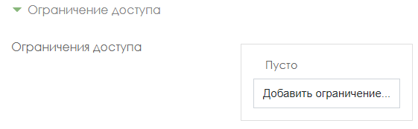
- Select Date
- Set the date and time when the test should be available for students to take
- When you are finished editing all settings, click Save and Return to Course. Appearance of the prepared element Test on the zero week of the course:

Moodle uses several basic types of test questions:

Multiple choice
Multiple choice (the student chooses the answer to the question from several options offered to him, and the questions can suggest one or several correct answers at once)

Add New question Multiple choice Add.

1. Write the name of the question: Question number 1,2,3….
2. Enter the text of the question;
3. Enter a score for each correct answer: 1 or 2, etc.

- We enter the answer options, here the first option is the correct answer, therefore the Score tab indicates 100% (If your test has several correct answers, for example, 2 correct answers, then in the first answer option, the Score tab: 50% and on the second answer option, indicate the Score: 50% ). In the wrong answer, the Rating tab: Empty. Thus, we enter all the answers.
5. Click the Save changes button.

True / False
AddNew questionTrue / False Add.
True / False (student chooses between two options True and False)
1. Write the name of the question: Question number 1,2,3….
2. Enter the text of the question;
3. Enter a score for each correct answer: 1 or 2, etc.
4.Choose the correct answer: True or False
5. Click the Save changes button.

Compliance
For correspondence (each element of the answers of the first group must be matched with an element of the answers of the second group)
AddNew questionTrue / False Add.

- Write the name of the question: Question number 1,2,3….
- Enter the text of the question;
- Enter a score for each correct answer: 1 or 2, etc.
- Compare the questions and answers.
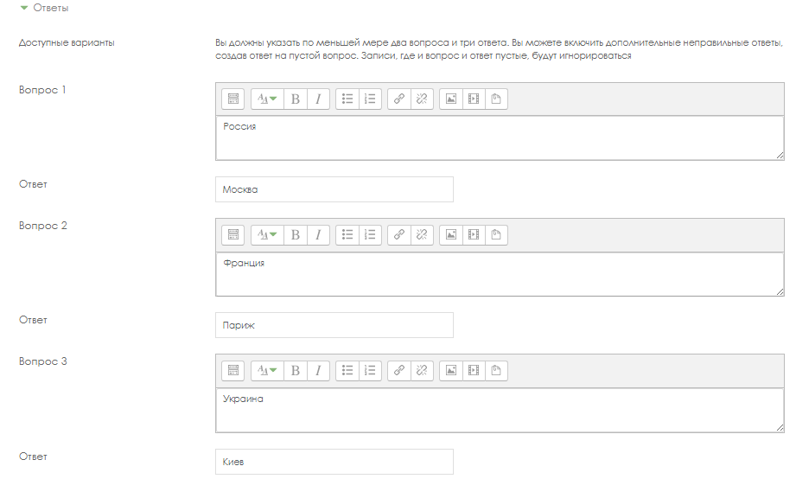
- Click the Save changes button.

Short Answers
- Short answers (the answer to the question is a word or short phrase, several correct answers with different grades are allowed)

- AddNew questionTrue / False Add.

- Write the name of the question: Question number 1,2,3….
- Enter the text of the question;

- Enter a score for each correct answer: 1 or 2, etc.

- Enter the answer options and indicate the correctness Score: 100%.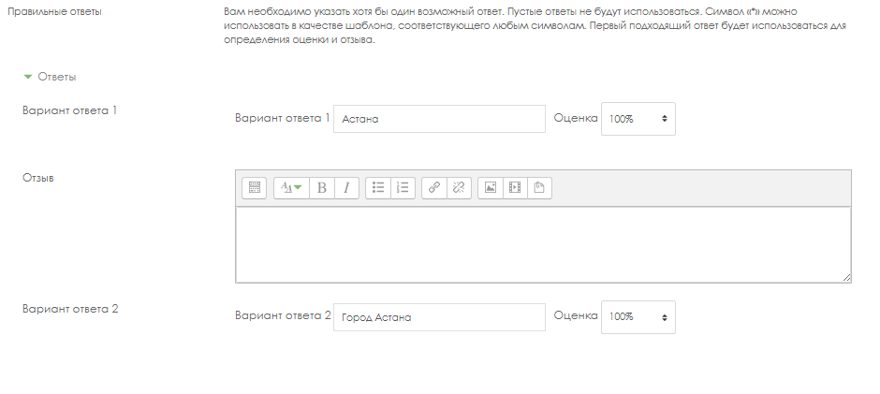
- Click the Save changes button.

Numerical
Numerical (the same as a short answer, only for performing computational operations, a numerical answer can have a specified interval of the maximum permissible error of deviation from the correct value);

AddNew questionTrue / False Add.

1. Write the name of the question: Question number 1,2,3….

2. Enter the text of the question;
3. Enter a score for each correct answer: 1 or 2, etc.

4. Enter the Variant of the answer, you can specify the Error, Estimation if the correct answer is 100%.
5. Click the Save button.

Calculated
Calculated (this question suggests calculating a value using a formula. A formula is a template into which random values from the specified ranges are substituted for each testing);

AddNew questionTrue / False Add.

1. Write the name of the question: Question number 1,2,3….
  - Enter the text of the question;
3. Enter a score for each correct answer: 1 or 2, etc.

4. In the Answers tab, enter the correct formula, indicate the Score of 100%.

5. In the tab Several attempts, the penalty for each wrong attempt is set to 0%.
- Click the Save changes button.

Nested responses
Nested answers are text directly into which short answers, numeric answers, or multiple choice are inserted, as in a "workbook";
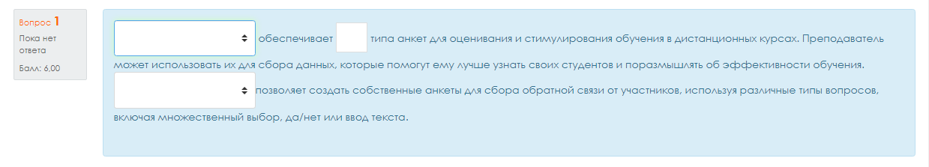
AddNew questionTrue / False Add.

1. Write the name of the question: Question number 1,2,3….
  - Enter the text of the question;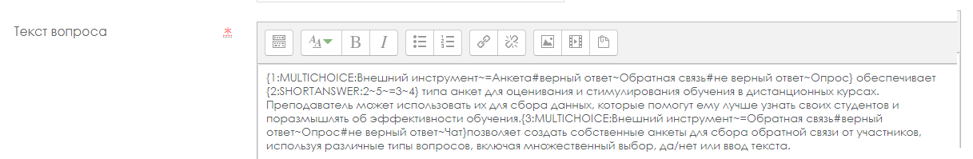

3. Enter a score for each correct answer: 1 or 2, etc.
4. Format of nested questions:
- all questions must be enclosed in curly braces: {};
- There can be a number between the open curly brace and the colon: the score for this question. For example, "{2:". To evaluate "1" the number can be omitted: "{:";
- after the colon must be the type of question: MULTICHOICE_S (multiple choice), SHORTANSWER (short answer), NUMERICAL (numeric);
- the syntax of multiple choice and short answer is the same, they will just be displayed to the learner differently;
- the order of answer options may be different;
- the correct answer is preceded by "=" or percentages (usually "% 100%");
- the wrong answer is not preceded by anything, or is preceded by percent (usually "% 0%");
- you can indicate any degree of correctness of the answer in the range from 0 to 100, if you enter the appropriate percentage;
- all answer options, except for the first one, are separated from the previous one by "~";
- for each answer option, a comment can be specified, which begins with the "#" symbol. If there is no comment, the "#" symbol is indicated or not - it does not matter. The comment is displayed in a small window that pops up when you hover the mouse (if comments were enabled in the test settings). The window is named "Comment" and HTML tags can be used to format it. However, you cannot use double quotation marks in the syntax, and TeX and Algebra filters do not work for comments;
- in a question of the "Short answer" type, you can add a comment for any incorrect answer, except those explicitly listed. To do this, use the asterisk symbol as the most recent answer: "*";
- unfortunately, in a question like "Short answer" it is impossible to check the case dependence (answers "Text" and "Text" will be the same).
- Consider in detail the following example (including dwelling on the peculiarities of the syntax of numeric responses):
- {1: MULTICHOICE_S: External tool ~ = Questionnaire # correct answer ~ Feedback # wrong answer ~ Poll} provides
- {2: SHORTANSWER: 2 ~ 5 ~ = 3 ~ 4} type of questionnaire for assessing and stimulating learning in distance courses. The teacher can use them to collect data that will help him get to know his students better and reflect on the effectiveness of teaching.
- {3: MULTICHOICE_S: External tool ~ = Feedback # correct answer ~ Poll # incorrect answer ~ Chat} allows you to create your own questionnaires to collect feedback from participants using different types of questions, including multiple choice, yes / no, or text input.
- In the "Several attempts" tab, remove the default for each attempt: 0%.
6. Click the Save changes button.

Essay
Essay (the student summarizes his view of the problem under consideration)
AddNew questionTrue / False Add.

1. Write the name of the question: Question number 1,2,3….
2. Enter the text of the question;
3. Allows a response from several sentences or paragraphs. Must be manually assessed by the instructor.
4. Select the response format: Plain text or HTML editor with file selection
5. Select in the Require text field: Require the student to enter text

6. Select how many lines should be in the Field Size field:

7. Select from the list Allow Attachments: 1 or 2

8. Select in the list Attachments are required: 1 or 2
9. Click the Save changes button.

For all questions you can contact:

Musinova Asel Akhmetovna (Director of INET)
8 701 722 6784, assel.moussinova@kaznu.kz

Smagulova Shynar (leading specialist)
8 777 825 51 90, shynar.smagulova@kaznu.kz

Mankeeva Anel (leading specialist)
8 707 949 94 18,
anel.mankeyeva@kaznu.kz

Zhabayev Talgat (software engineer)
8 72 750 86 98; 8 747 353 37 58.
talgat.zhabayev@kaznu.kz

Appendix 2

Description of the settings for limited access in Moodle LMS
for exams: project, creative task, case task, essay

Go to edit mode, click Add item or resource.

Select the required item from the drop-down list.

On the page that opens, set up an element, enter a Title, description, you can attach a document.
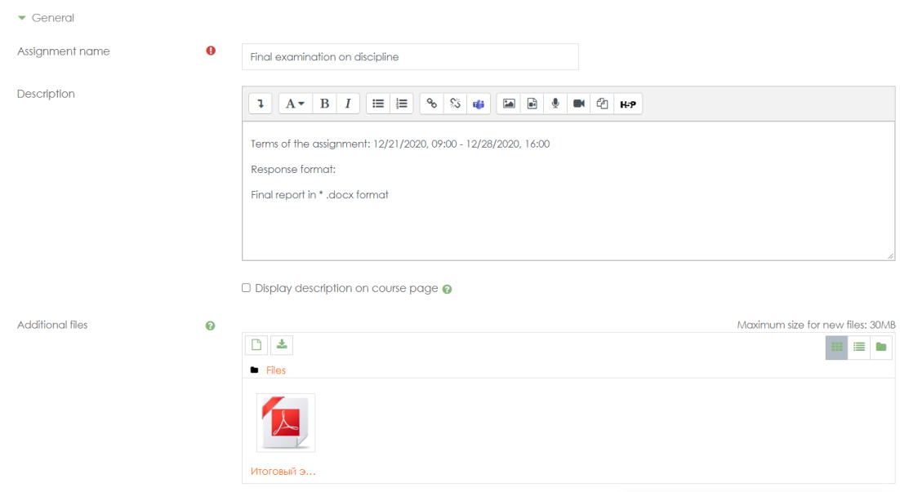

In the Available tab, set the deadlines.

In the tab Types of responses provided, select the type of response, and set the number of attached files.

In the Access restriction tab, click the Add restriction button.
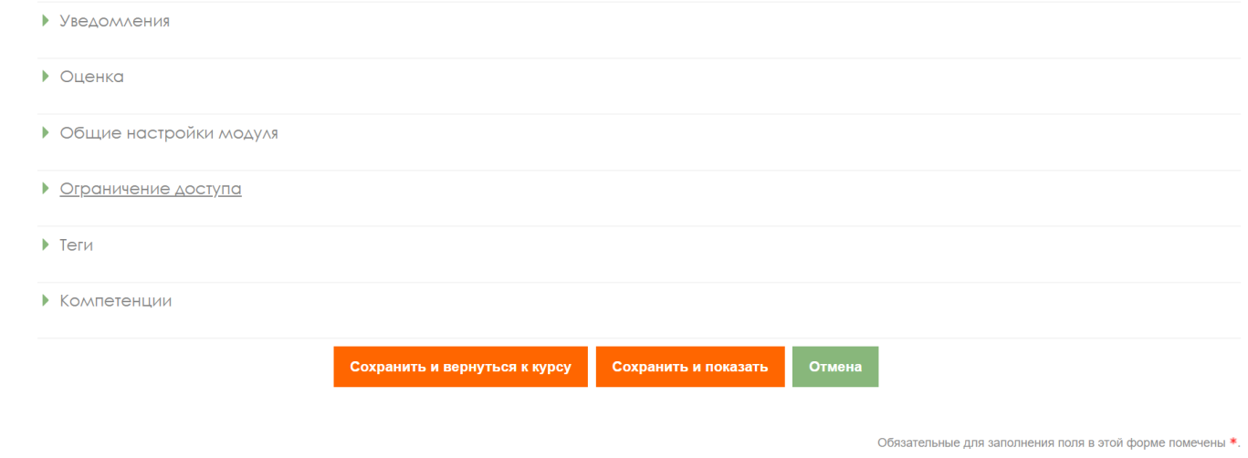
Click on the Add Description button
Click the Date button

Set a date when the assignment should become available to the student.

Click save and return to course.

Appendix 3

Rules for the design of test tasks for IS Univer

1. Questions and his answers must be in tabular form.

2. The number of answers to one question: from 5 to 8.

3. For the text of the question, the indicator is indicated:

• V1, in case of one correct answer,

• V2, in case of multiple (two or three) correct answers

4. For correct answers, the number is indicated - 1, for incorrect answers the digit is indicated - 0.

5. It is allowed to use pictures in the question, formulas must be typed formula editor in Microsoft Word.

Test set design template for IS Univer

Faculty:

Department:

Lecturer:

Discipline:

Course:

Number of students:

Contact phone / email mail:

Question №1
V1 | Question text №1
0 | incorrect answer
1 | correct answer
0 | incorrect answer
0 | incorrect answer
0 | incorrect answer

Question №2
V1 | Question text №2
0 | incorrect answer
1 | correct answer
0 | incorrect answer
0 | incorrect answer
0 | incorrect answer

Question №3
V1 | Question text №3
0 | incorrect answer
1 | correct answer
0 | incorrect answer
0 | incorrect answer
0 | incorrect answer
Question №4
V1 | Question text №5
0 | incorrect answer
1 | correct answer
0 | incorrect answer
0 | incorrect answer
0 | incorrect answer

Question №5
V2 | Question text №6
0 | incorrect answer
1 | correct answer
0 | incorrect answer
0 | incorrect answer
0 | incorrect answer
1 | correct answer
0 | incorrect answer
1 | correct answer

Question №6
V2 | Question text №7
0 | incorrect answer
1 | correct answer
0 | incorrect answer
0 | incorrect answer
0 | incorrect answer
1 | correct answer
1 | correct answer

Question №7
V2 | Question text №8
1 | correct answer
1 | correct answer
0 | incorrect answer
1 | correct answer
0 | incorrect answer

etc.

Appendix 4

Full report in the Antiplagiat system

The text of Appendix 4 was prepared based on the “Antiplagiat.VUZ” corporate version lecturer’s manual” dated 02.09.2019. Author is “Anti-Plagiarism” JSC.

After downloading and checking the document, lecturer opens full report.
The full report includes:
- assessment for suspiciousness and the ability to go to the suspicious page;
- a list of borrowing sources with the ability to edit and go to the report by source;
- continuous or page-by-page display of the full text of the checked document with the selection of found borrowed blocks;
- date of verification of the document;
- display of report corrections.

The figure below shows a general view of the full report.
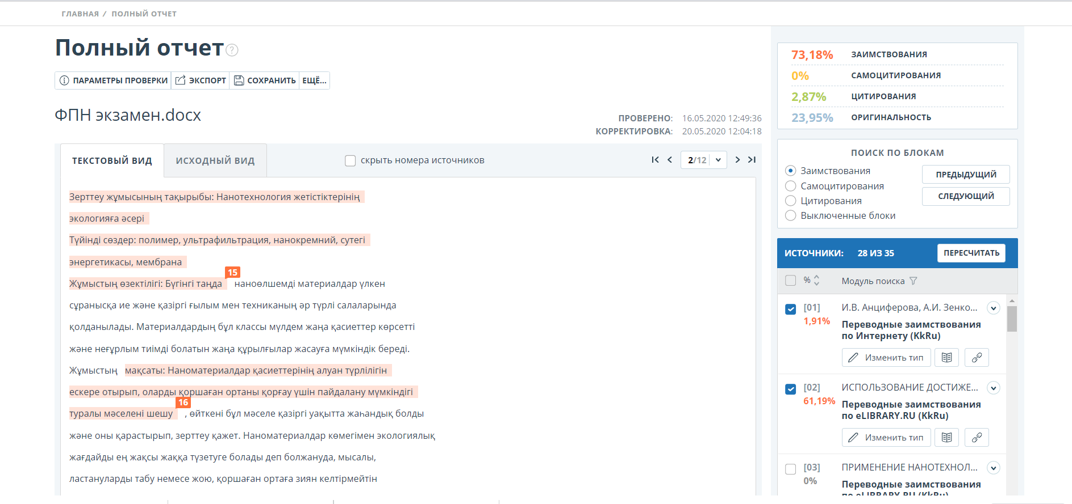

Review of the full report:
The report page consists of the checked text, in which the borrowing blocks are highlighted, a list of sources, aggregated check results and navigation through borrowing blocks (search by blocks).
Use the paging bar above and below the text box to navigate through the pages of text. To display all pages of the document at once, click on "Show all pages" at the bottom of the document page.
To see which specific fragments of text were borrowed and from which specific source, all borrowing blocks in the system are highlighted in color, and at the end of each block there is a label with the serial number of the source.
When viewing the borrowed blocks in the report, you can use block navigation (block search). With it, you can go to the next or previous block by pressing the "Previous" or "Next" buttons. You can also choose which blocks to navigate - by blocks of quotation or borrowing.

Viewing source information
To view information about a source in the list of sources, open the source you are interested in and click on the "book" icon. To follow the link to the source itself, click the "chain" icon.

Source information in the source list

Another way to view information about a source is to click on the source number in the text of the full report. A window will be displayed containing basic information about the source.

On the full report page, lecturer examines the links to the discovered sources in the student's work in more detail, disables / enables the corresponding blocks in the Sources list and recalculates the result of the full originality report by clicking on the "Recalculate" button.

ATTENTION! If the full report is marked as "Suspicious Document" and you see a warning sign, it means that a technical workaround has been completed (replacing symbols, inserting extra symbols, omissions, etc.). Such works, after analyzing the full report, are subject to cancellation.

Appendix 5

SAMPLE COURSERA CERTIFICATE
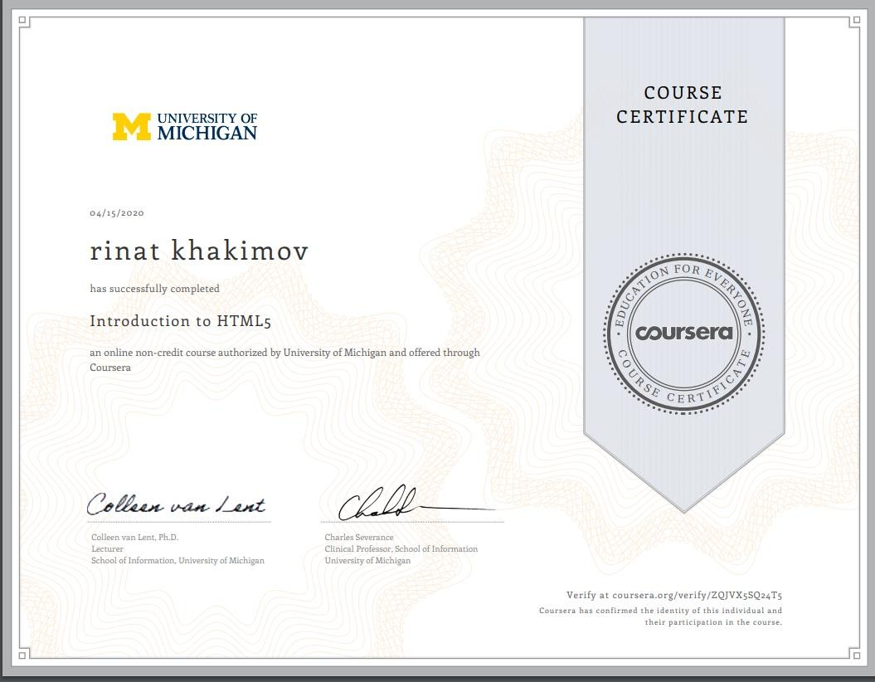
SAMPLE listener profile page with scores on COURSERA
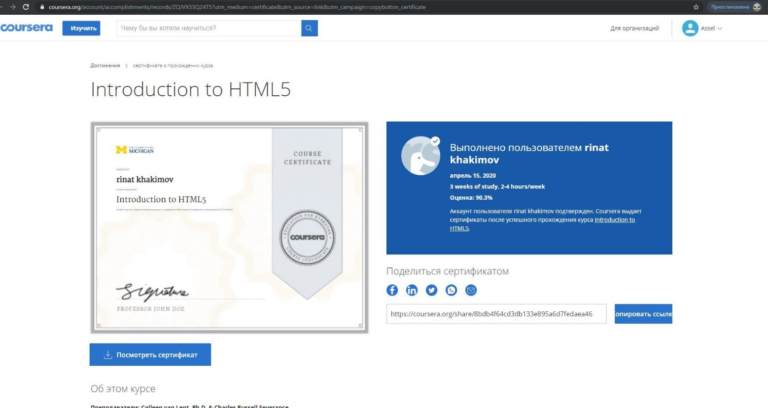

Appendix 6
The list of assessment tools for current, final control
Name of the estimated tool | Brief description of the evaluation tool | Presentation of the evaluation
Control work | A tool for testing the skills to apply the acquired knowledge to solve problems of a certain type on a topic or section | Set of control tasks by options
Colloquium, interview | A means of monitoring the assimilation of educational material of a topic, section or sections of a discipline, organized as  training session in the form of an interview between a teacher and a student | Questions on topics (sections) of the discipline
Essays, abstracts, reports, messages | Essays, abstracts  A tool for monitoring the ability to work with information, its analysis, structuring, drawing conclusions and recommendations.  Reports, messages  The product of a student's independent work, which is a public speech on the presentation of the results obtained on a specific educational-practical, educational-research or scientific topic.  Shows the ability to reveal the essence of the problem under study. | A set of topics
Business and (or) role play | Joint activities of a group of students under the guidance of a teacher in order to solve educational and professionally oriented tasks by means of game modeling of a real problem situation. Allows you to assess the ability to analyze and solve typical professional  tasks | Topic (problem) concept, roles and expected result for each game
Case - assignement | A problematic task in which the student is asked to comprehend a real professionally-oriented situation necessary to solve this problem | Tasks for solving a case problem
Round table, discussion, polemics, debate | Assessment tools that allow students to be included in the process of discussing a controversial issue, problems and assess their ability to argue their own point of view. | List of discussion topics for a round table, discussion, polemics, dispute, debate
Portfolio | A targeted selection of student works, revealing his individual educational achievements | Portfolio structure
Project | Independent study work performed during the academic semester (course).  Allows you to assess the ability of students to independently apply their knowledge in the process of solving practical problems and problems, navigate in the information space and the level of formation of analytical, research skills, practical and creative  thinking. | Topics of group and (or) individual projects
Workbook | A didactic complex for independent work of a student, allowing assess the level of mastering the educational material | Sample workbook
Physical and virtual hardware lab | It can be performed individually or by a group of students.  Lab assignments should include an element of creativity and teamwork. There is a project assignment (it is better to formulate it this way, and not a description of the course of the laboratory work), there is a lead time, there is a moderator represented by a teacher who can direct the team's reasoning and actions in the right direction. Allows you to assess the ability of students to independently construct their knowledge in the process of solving practical problems and to assess the level of formation of analytical, research skills, as well as skills of practical and creative thinking. Allows you to assess the ability to professional labor actions | Individual or group assignments
Multilevel tasks | There are several tasks:  a) reproductive level, allowing to assess and  diagnose knowledge of factual material (basic concepts, algorithms, facts) and the ability to correctly use special terms and concepts, recognition of objects of study within a certain section of the discipline;  b) the reconstructive level, allowing to evaluate and diagnose the ability to synthesize, analyze, generalize factual and theoretical material with the formulation of specific conclusions, the establishment of cause-and-effect relationships;  c) a creative level, allowing to evaluate and diagnose skills, integrate knowledge of various fields, argue their own point of view, which allows us to assess the ability to work. | A set of multi-level tasks and tasks
Computational and graphic work | A tool for testing the skills to apply the acquired knowledge according to a predetermined methodology for solving problems or tasks in a module or discipline as a whole. | Set of tasks for performing computational and graphic work
Abstract | The product of the student's independent work, which is a summary in writing of the results of the theoretical analysis of a certain scientific (educational and research) topic, where the author shows the ability to reveal the essence of the problem under study, gives various points of view, as well as his own views on it. | Abstract topics based on learning outcomes
Creative task | Partially regulated task that has a non-standard solution and allows you to diagnose skills, integrate knowledge of various fields, and argue your own point of view. Can be performed individually or as a group students. | Topics for group and / or individual creative assignments
Simulators (can be virtual) | A technical tool that can be used to control the professional skills and abilities acquired by the student in managing a specific material object. | Set of tasks for working on the simulator

Appendix 7

RULES FOR SETTING UP THE SELECTION OF FINAL CONTROL FORM AND PLATFORM
Table. Rules for setting up the selection of final control form and platform

EXAMINATION PLATFORM  EXAMINATION FORM | Examination platform | Examination form | Type of examination | Supplementary information | Final control program
1. Written examination:  traditional-answers to  questions LMS Oqylyq | LMS OQYLYQ | WRITTEN | Traditional answers to questions | Do not fill in | ATTENTION! MANDATORY TO IMPLEMENT.  FOR ALL FORMS AND PLATFORMS OF FINAL CONTROL.  - Attach a file with the exam program and instructions on the technology and methodology of the exam (all information  in one document) to the EMCD, in the section "Final control program for the discipline".  - Only after downloading the file will be reflected in the "Final control program" section.  If you have several files attached to the EMCD, select the required file from the drop-down list.
2. Written examination:  traditional-answers to  questions UNIVER system | UNIVER | WRITTEN | Traditional answers to questions | Do not fill in
3. Examination-testing in  UNIVER IS | UNIVER | TESTING | - | Do not fill in
4. Oral examination:  traditional-answers to  questions | UNIVER | ORAL | - | Enter the selected form:  MS Teams, BigBlueButton, Zoom or another one.
5. Written examination:  project | LMS MOODLE | WRITTEN | Project | Do not fill in
6. Written examination: case | LMS MOODLE | WRITTEN | Case | Do not fill in
7. Written examination: essay | LMS MOODLE | WRITTEN | Essay | Do not fill in
8. Written examination:  creative assignment | LMS MOODLE | WRITTEN | Creative assignment | Do not fill in
9. Examination-testing in  Moodle LMS | LMS MOODLE | TESTING | - | Do not fill in
10.Combined examination  №1: written project with subsequent oral defense | LMS MOODLE | COMBINED | Combined examination №1  (2 parts) | Do not fill in
11.Combined examination  №2: project work using Miro interactive whiteboards with subsequent oral defense | LMS MOODLE | COMBINED | Combined examination №2  (2 parts) | Do not fill in
12.Combined exam №3: test + written project / case /  problem solution | LMS MOODLE | COMBINED | Combined examination №3  (2 parts) | Do not fill in
13. Alternative examination - transfer of MOOC  certificates (Coursera, Stepik, | ALTERNATIVE | TRANSFER OF CERTIFICATE POINTS | - | Enter the name of the MOOC platform: Coursera, Stepik, edX, etc.
14. Exam - testing in the StartExam system | StartExam Faculty of Medicine and Health Care only | TESTING | - | Do not fill in

